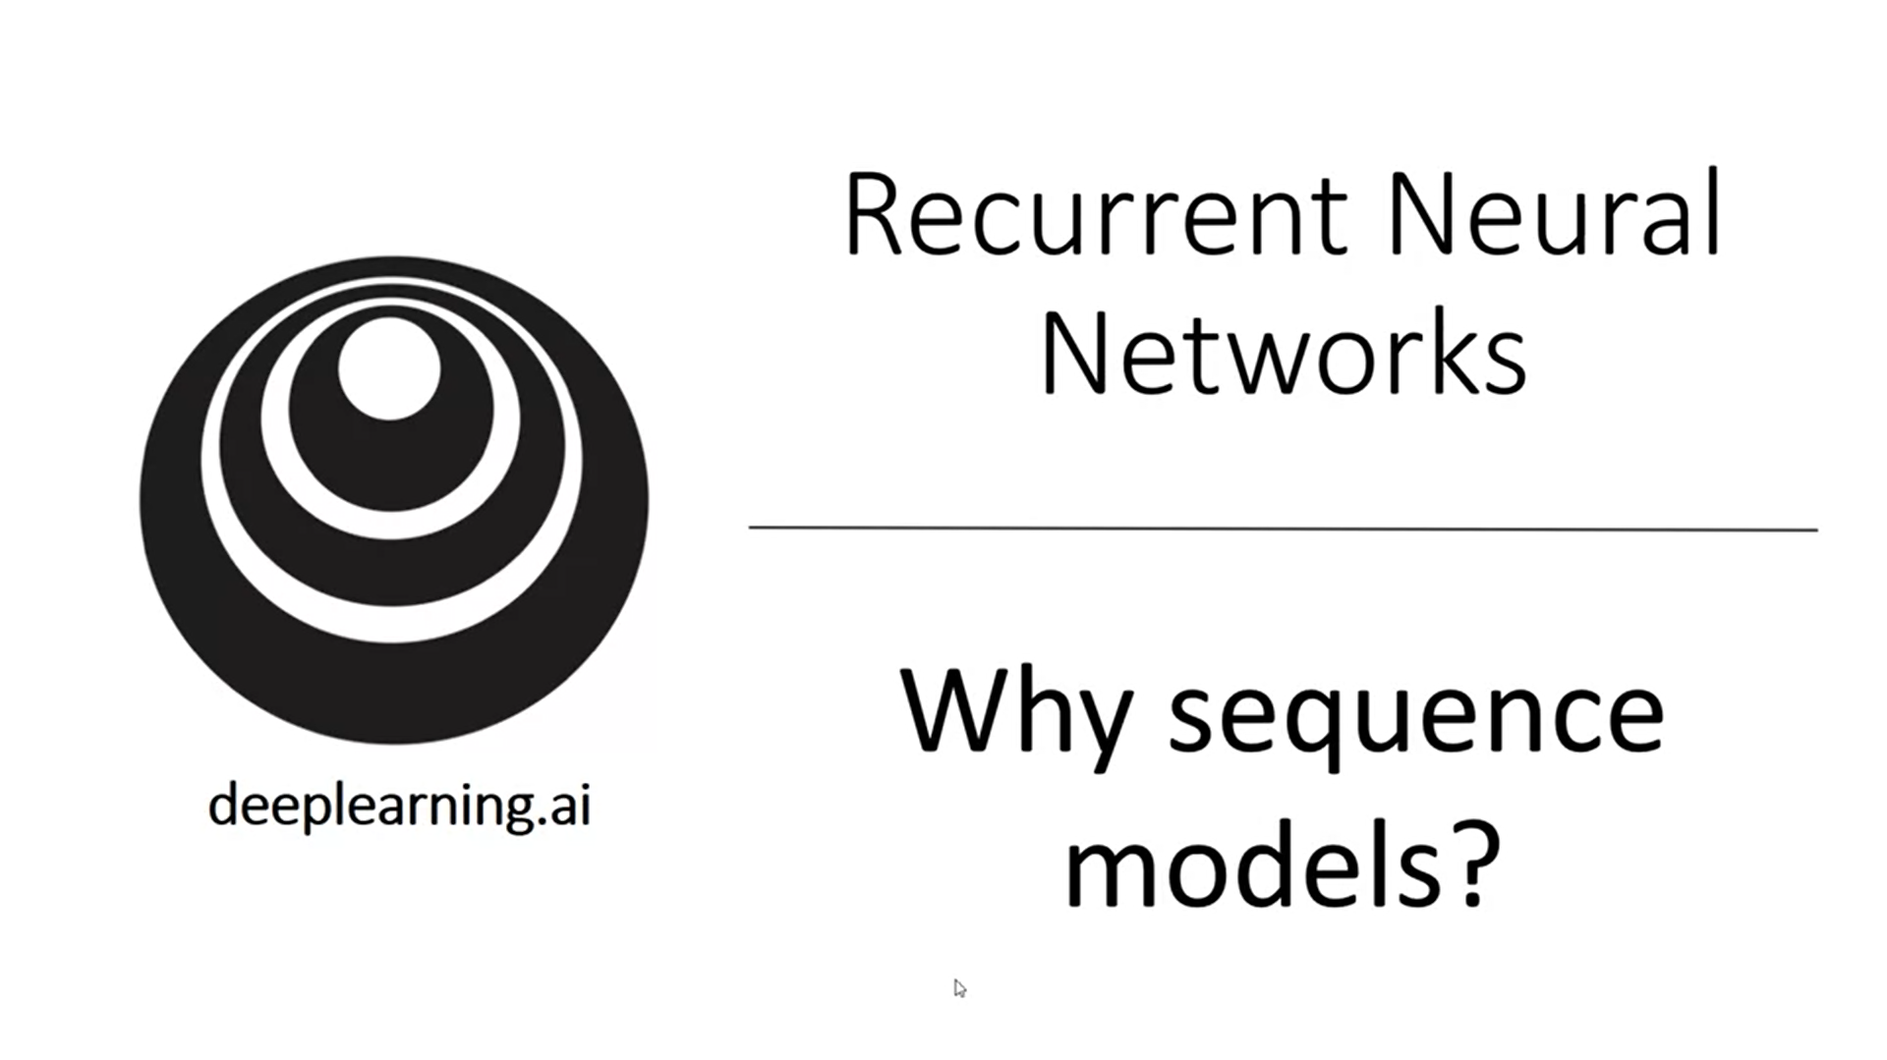

Sequence models have transformed speech recognition, natural language processing and other areas.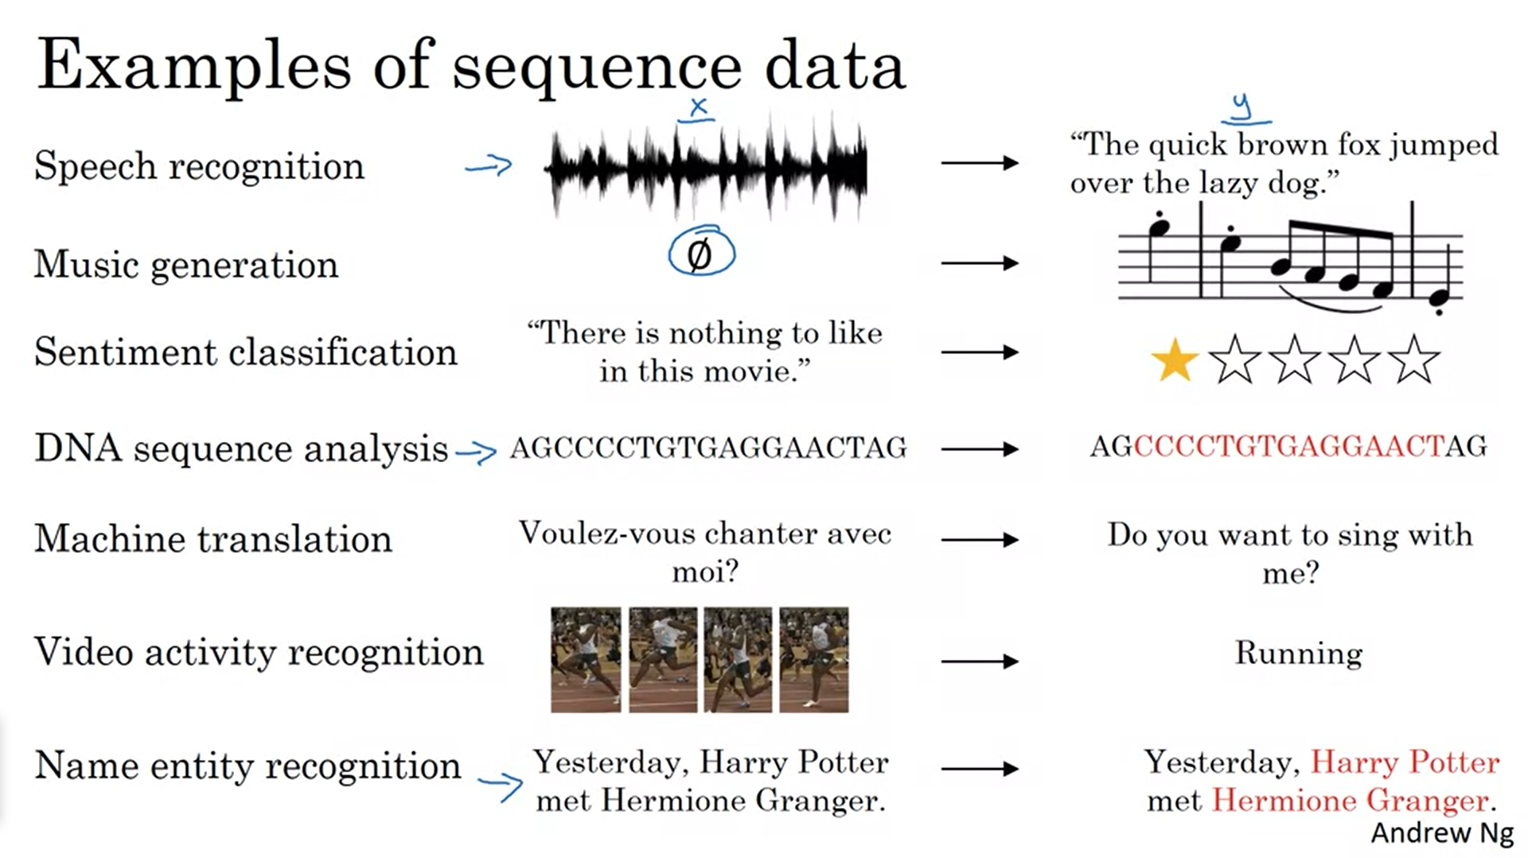

Speech recognition: both input (audio clip) and output (sequence of words) are sequence data

Music generation: only output is a sequence; input can be empty set or single integer referring to genre of music or first few notes of the desired output

Sentiment classification: only input is a sequence

DNA sequence analysis: given DNA input sequence, label part that corresponds to a protein

Machine translation: given input sentence, output sentence in different language

Video activity recognition: given a series of video frames, predict the activity

Name entity recognition: given a sentence, identify people in that sentence

All of these can be addressed as supervised learning with labeled data x,y. The examples show that there are lots of different types of sequence problems. X and y can both be sequences, sometimes with different lengths, or either x or y only can be a sequence.

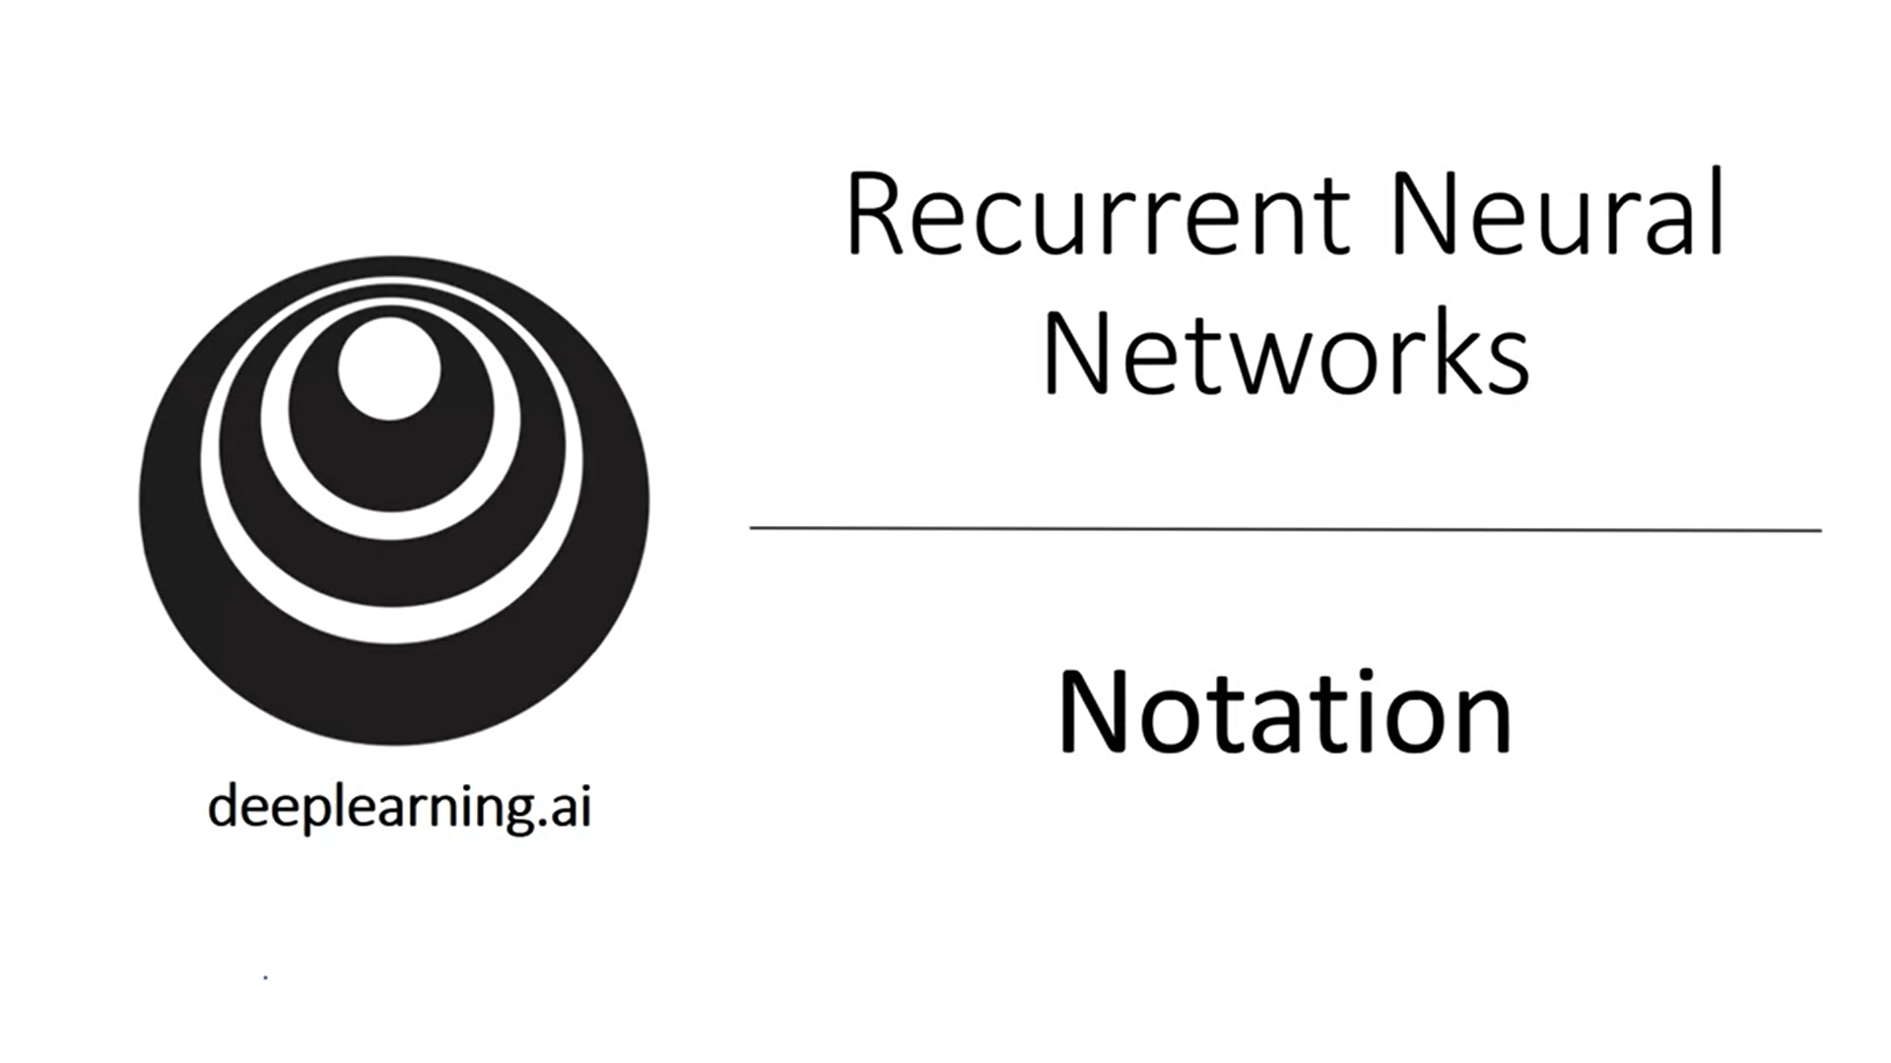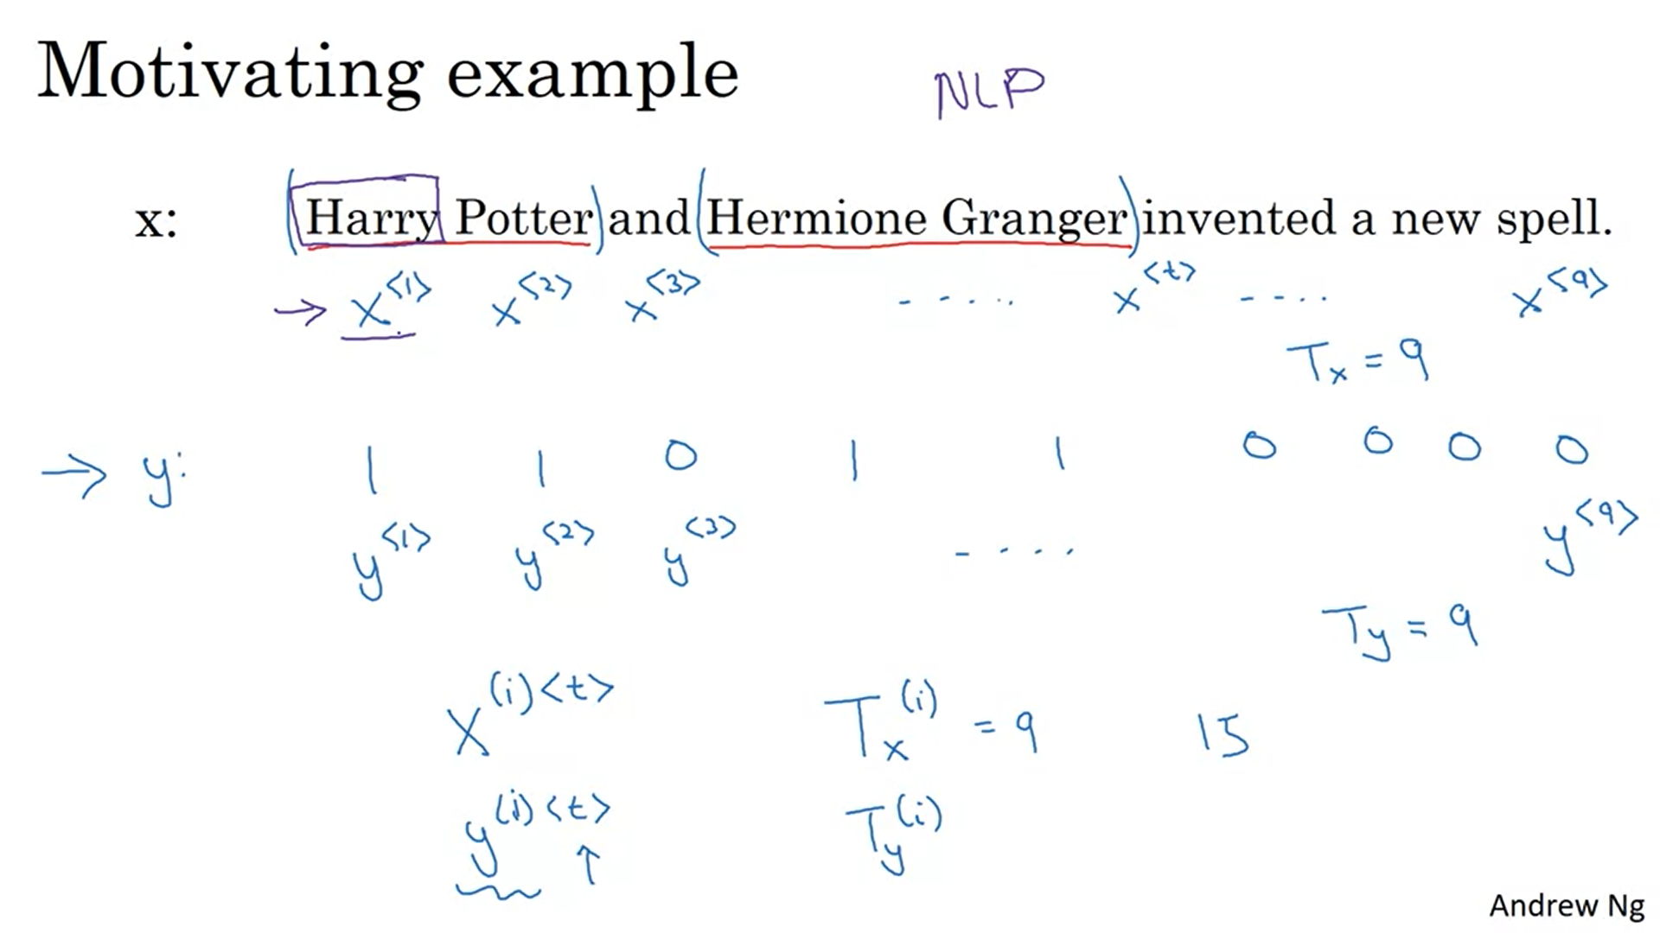

Sequence model shall tell us where are the names in this sentence -> name entity recognition. Used for example by search engines to index the latest news articles. Can be used to find people’s names, companies’ names, times, locations, country names, currency names etc.

Output y tells us for each input word whether that is part of a person’s name. Technically this is not the best output representation. Representation could take into account start and end of a person’s name in the sentence.

Index into different positions of input and output (<t>). Tx and Ty denote the sequence length (they can be different).

To refer to an example in our training set we still use (i). Different examples in the training set can have different lengths Tx(i) and Ty(i).

This is our first foray into NLP. We need to decide how to represent individual words in a sequence.

Come up with a vocabulary also called dictionary. This is composed of a list of words that are used in the representation. All words in the dictionary are indexed with their position. Here we have 10,000. This is quite small. More common is 30k-50k and also >100k is not uncommon. Large internet companies have maybe >1M.

One way to find this dictionary would be to look through the training set and find the top 10k most occurring words. Alternative would be looking at an online dictionary to find most common words in English language.

X’s are one-hot-encoded vectors -> whole sentence is represented with 9 vectors.

Goal: find a mapping using a sequence model to the target output y. We do this as a supervised learning problem.

What if we encounter a word that is not in the vocabulary? We create a new token <unk>.

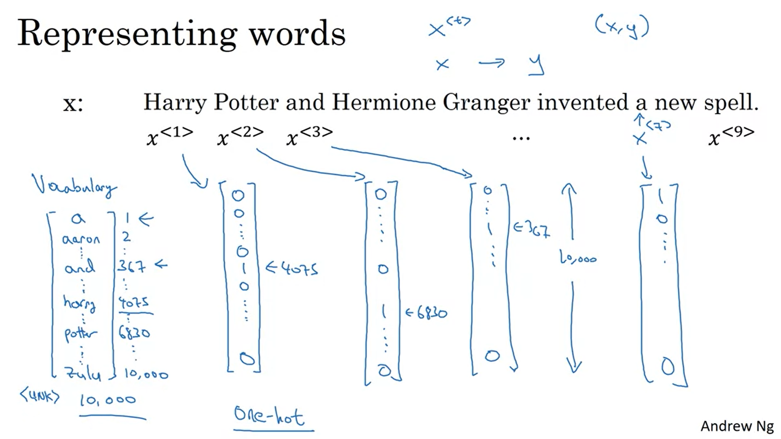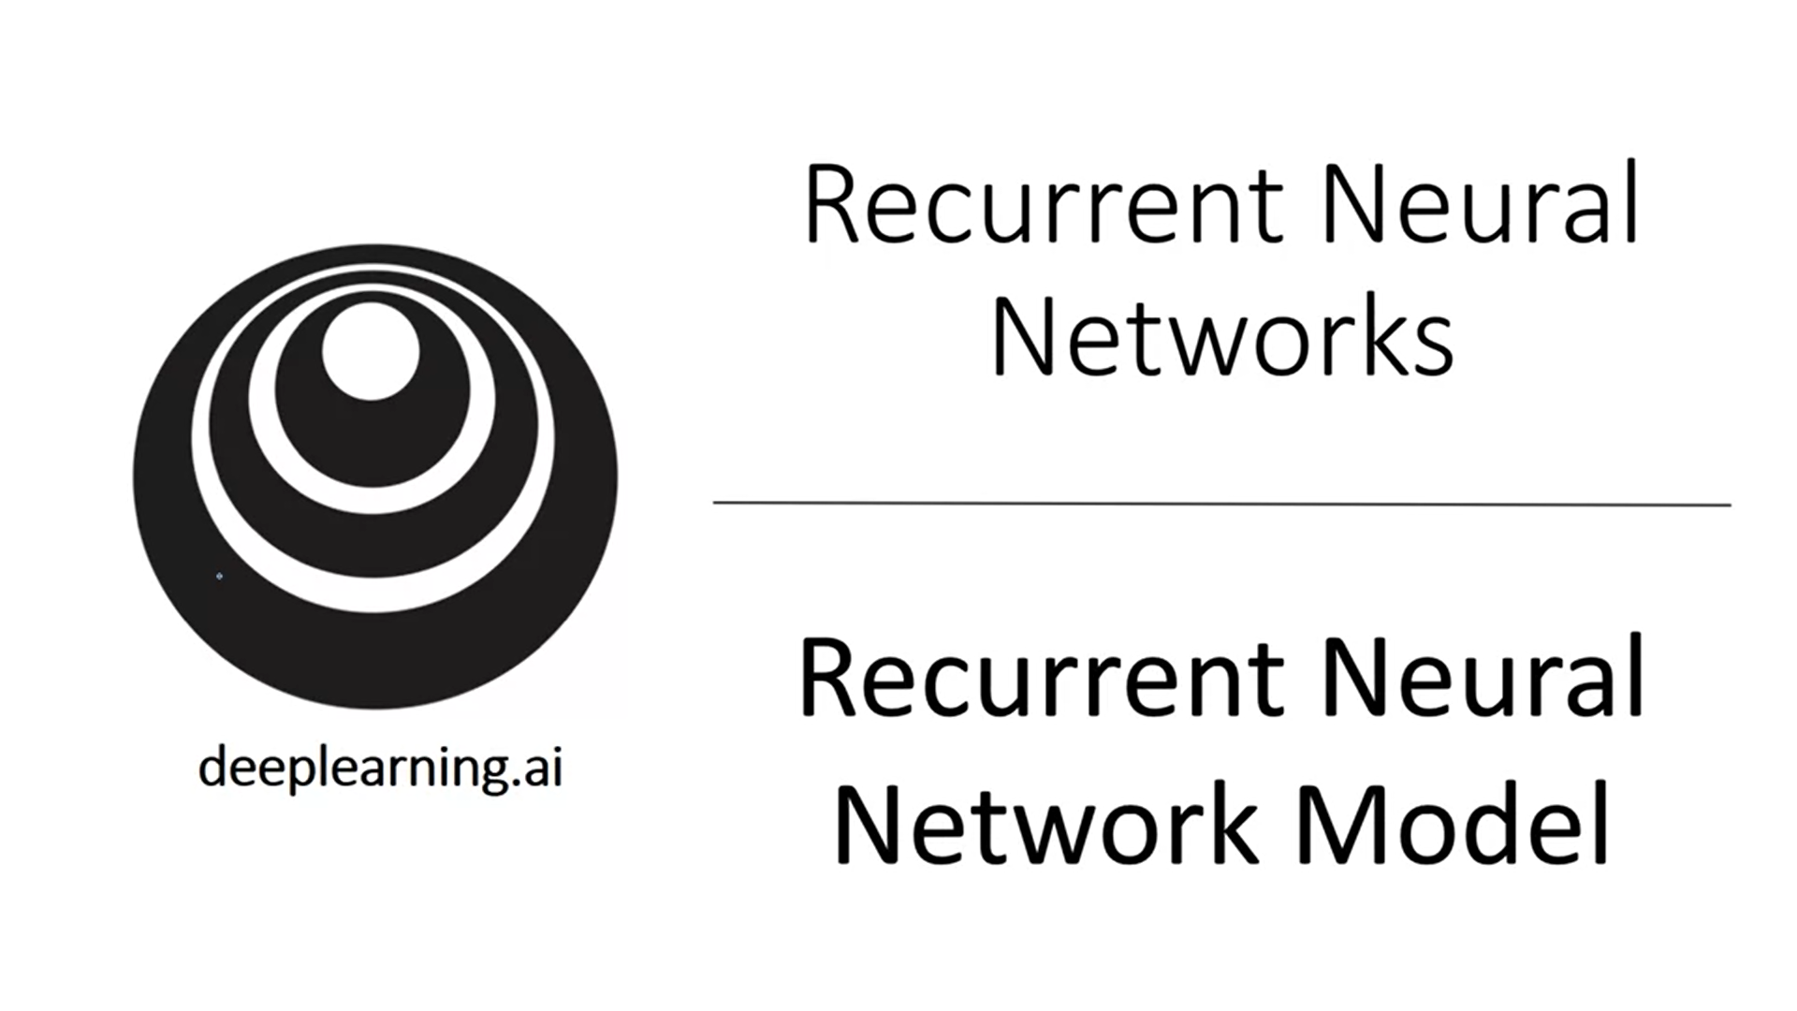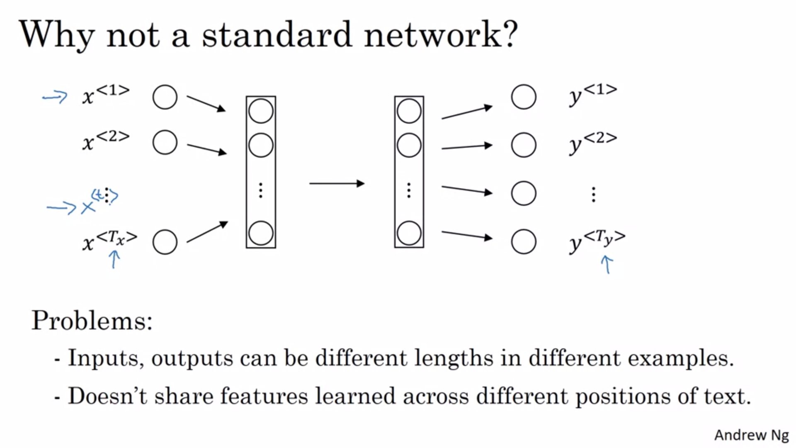

Now let’s talk about the model to map from x to y.

Two problems with using a standard neural network for sequences of data. One idea for problem 1 could be to pad to maximum input length but this will not be a good representation. Regarding problem 2, example of Harry is given: the model would have to learn at every position that Harry is a person -> we do not generalize well. We need a better representation to reduce number of parameters in the model. Especially since input layer is very large (max number of words * 10,000). This would be an enormous amount of parameters with a normal model.

RNN solves these two problems.

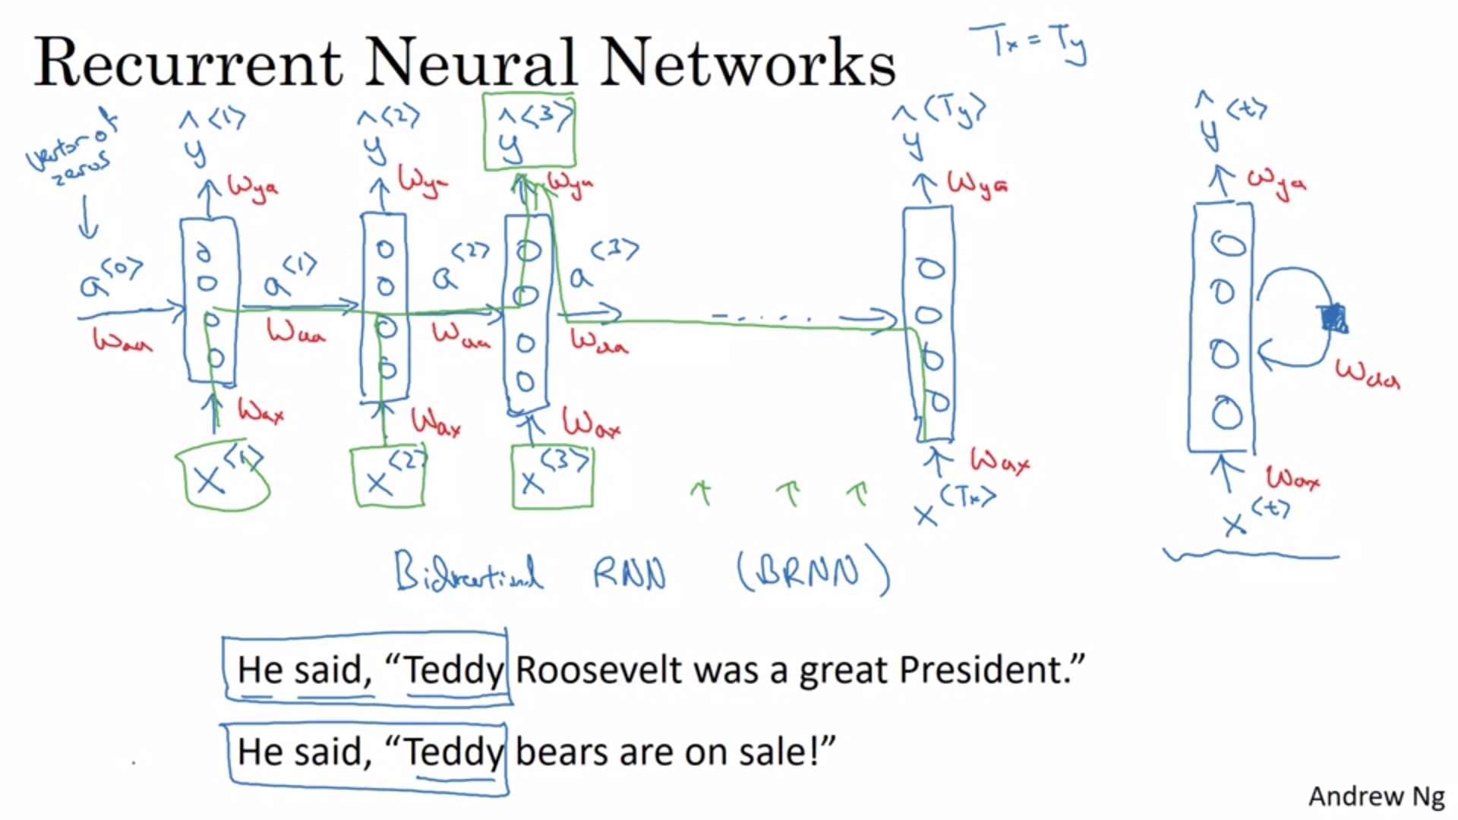

First word is fed into a neural network layer. When the neural network reads the second word it gets input information from time step 1. The activation value is passed on (up until the last time step).

To kick off the whole thing there is some made up activation at time step 0. This is usually a vector of 0s.

Two diagram representations of RNNs: unrolled vs loop to represent recurrence (shaded box denotes delay of 1 time step).

Recurrent neural network scans through the data from left to right. The parameters it uses for each time step are shared (the same parameters for every time step).

Parameters that govern the connection from x to the hidden layer: Wax.

Parameters that govern the horizontal connections: Waa.

Parameters that govern the output prediction: Way.

The prediction of y<3> for example will be influenced by x<1>, x<2> and x<3>.

Weakness of this RNN architecture: it only uses information from inputs that are earlier in the sequence. This will be addressed later through BRNNs. Example why this is problematic: Teddy sentence -> It would be useful to have information from subsequent words to determine if Teddy is a name.

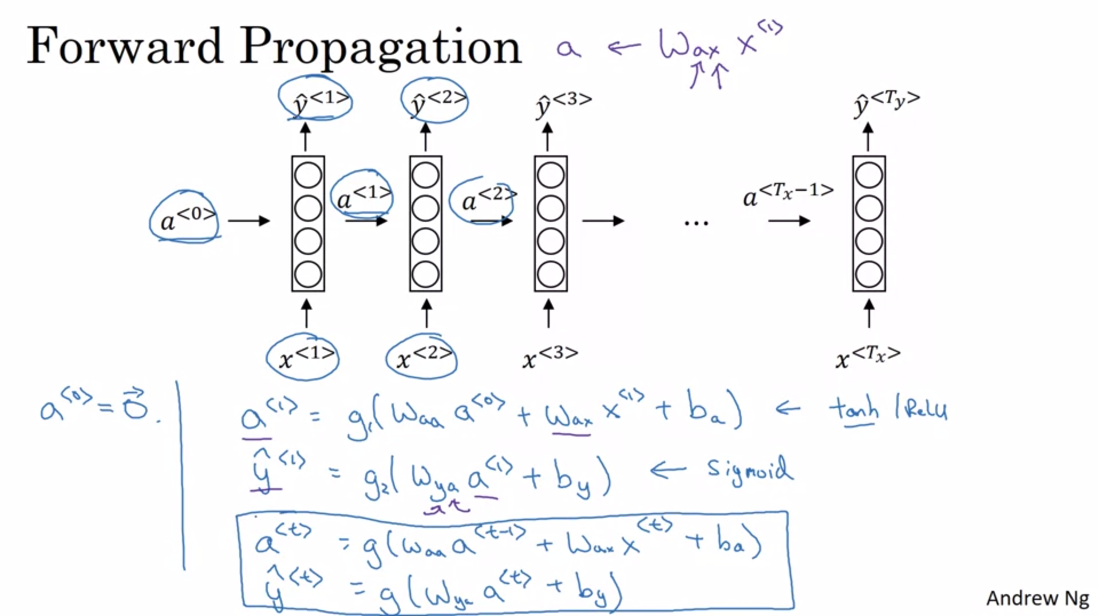

We start off with vector of all zeros. First step of forward prop is to calculate a<1>. Then we calculate the prediction at time step 1 y<1>.

Explanation of Wax -> x for being multiplied by some x-like quantity; a for being used to calculate some a-like quantity.

Tanh is a pretty common choice for activation functions for the hidden layer. There are other ways to avoid the vanishing gradients problem (ReLU is not needed).

Output activation function depends on desired output of y. For name entity recognition with binary output we can use sigmoid activation function.

Forward propagation: start with a<0> and calculate all y’s from left to right

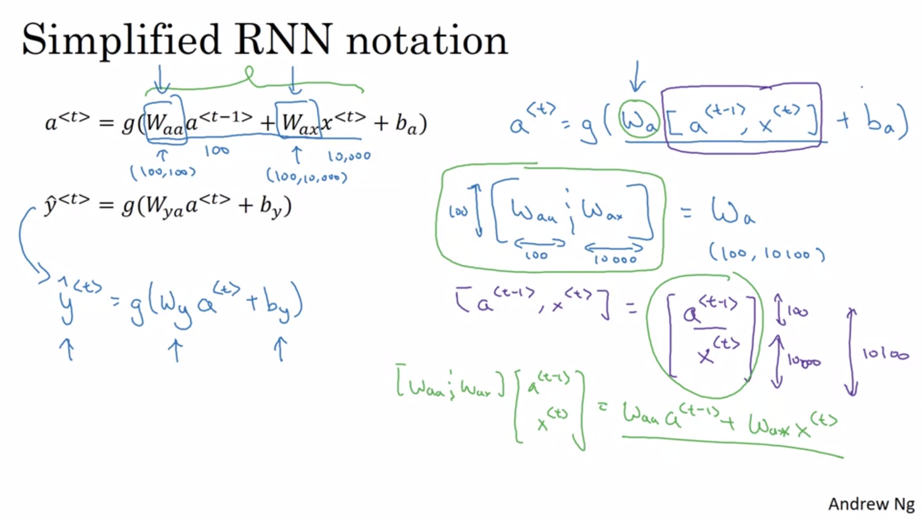

Stack Waa and Wax horizontally into Wa.

Stack a<t-1> and x<t> vertically.

New notation is equivalent as shown in green on right bottom of slide.

Now only output quantity is indicated in notation.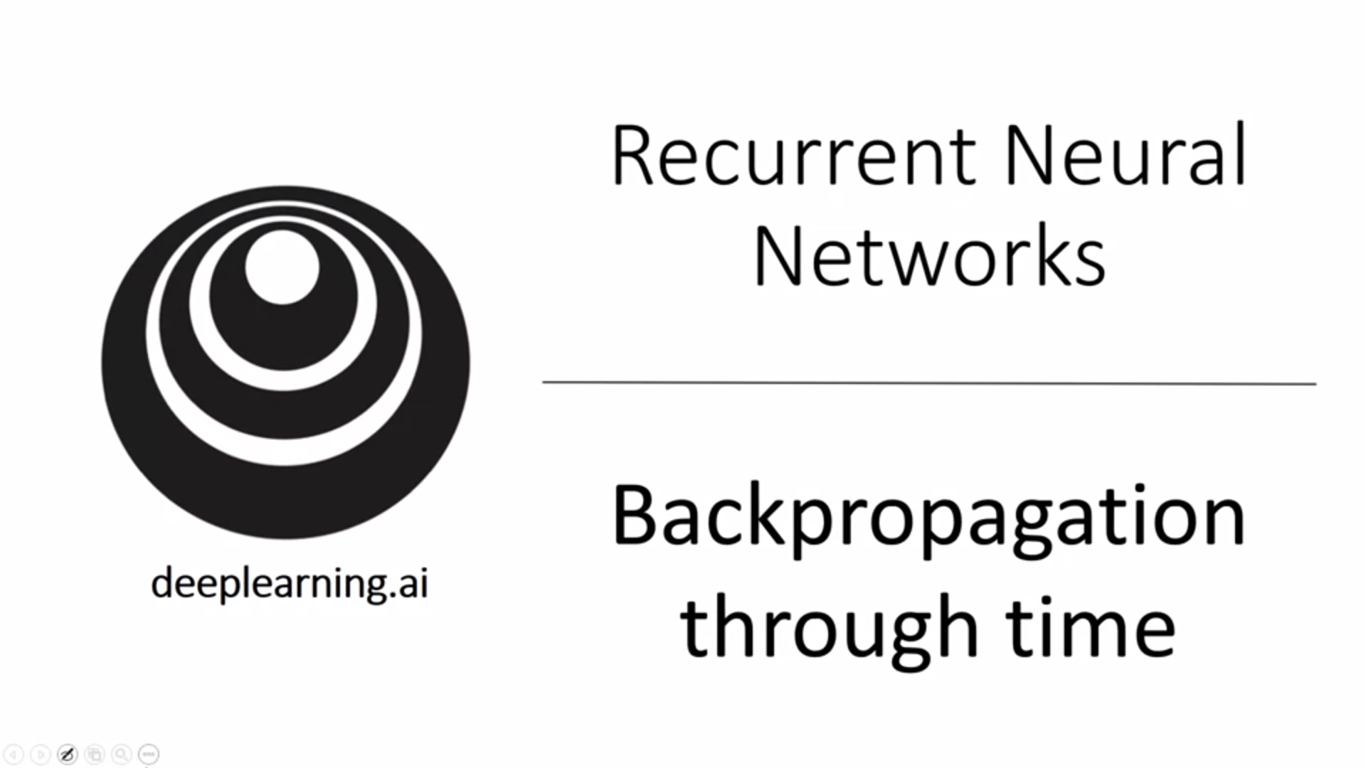

How does backpropagation in an RNN work? Usually this is taken care of by the deep learning framework but still useful to understand how it works.

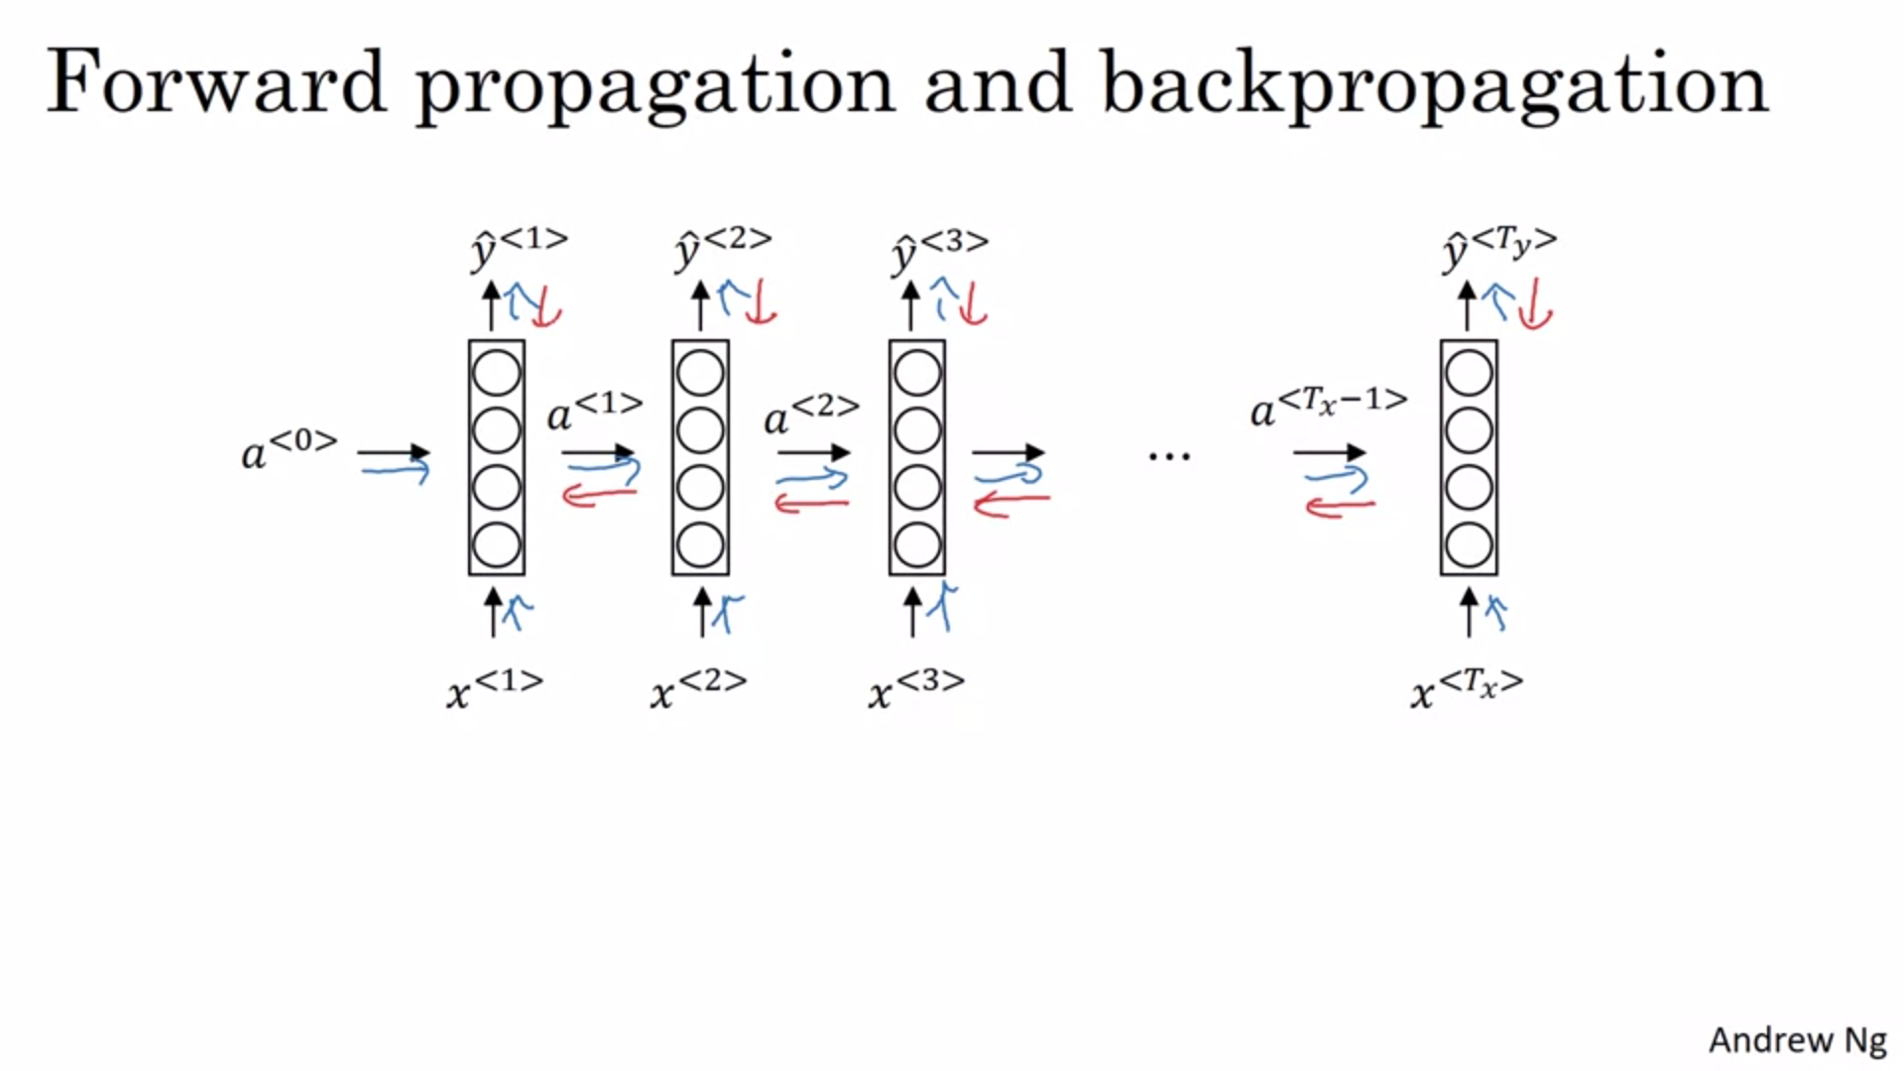

Opposite direction of forward prop arrows.

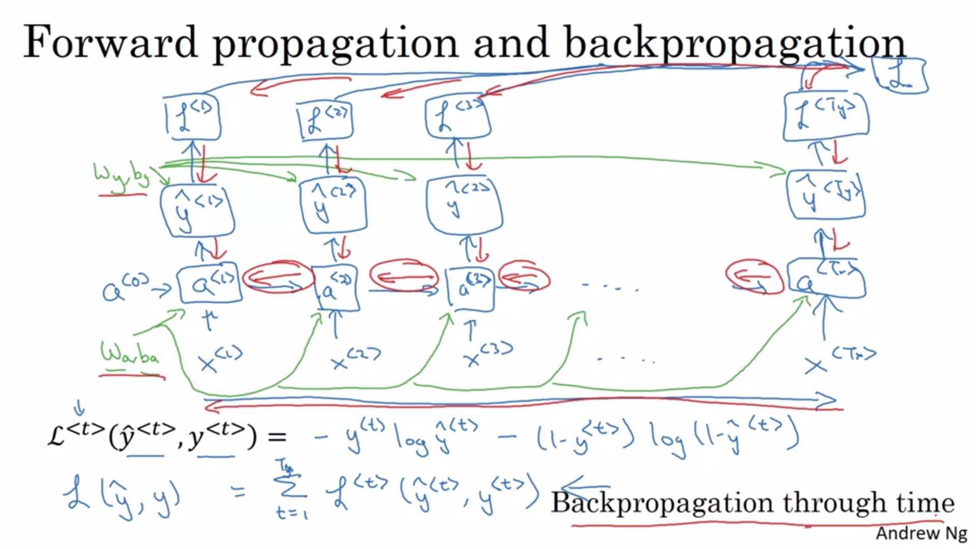

This is a computation graph.

Wa, ba are used for every single time step (green arrows).

Same for Wy, by to compute y_hat.

We also need the loss function for backpropagation. Here standard logistic regression loss (cross entropy loss).

The overall loss for the entire sequence is a sum over the individual losses for all time steps.

Backpropagation: Doing computations/passing messages in the opposite direction.

We calculate derivatives with respect to parameters and update the parameters with gradient descent.

The most significant recursive calculation is the one that goes from the right to the left -> backprop through time.

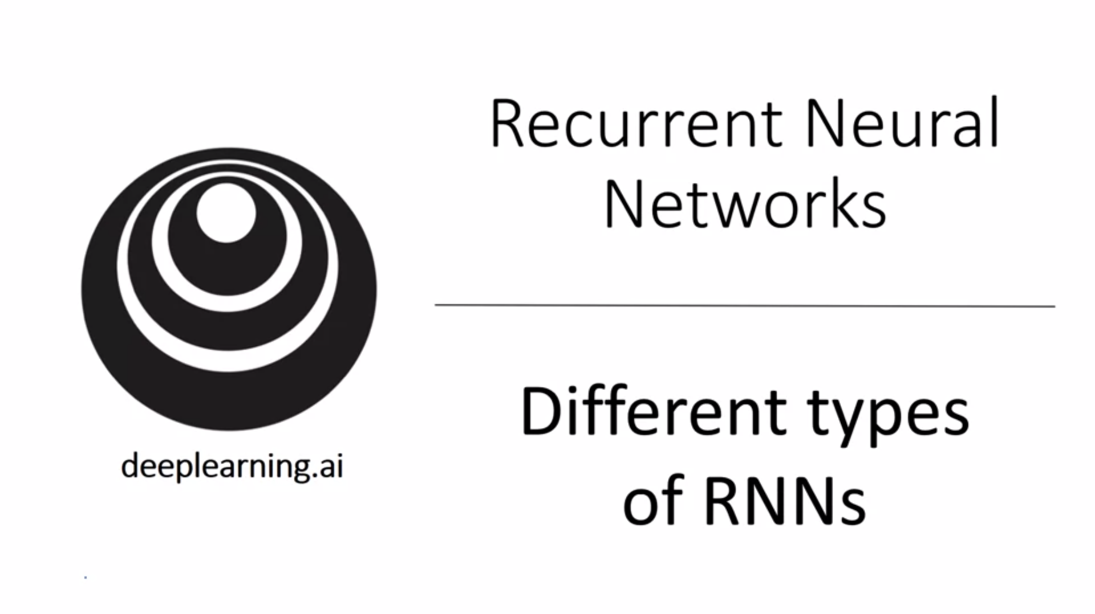

So far, the number of inputs was equal to the number of outputs. It turns out that for many applications Tx and Ty might not be the same. We can modify the RNN architecture to address all kinds of problems…

There are much richer RNN architectures.

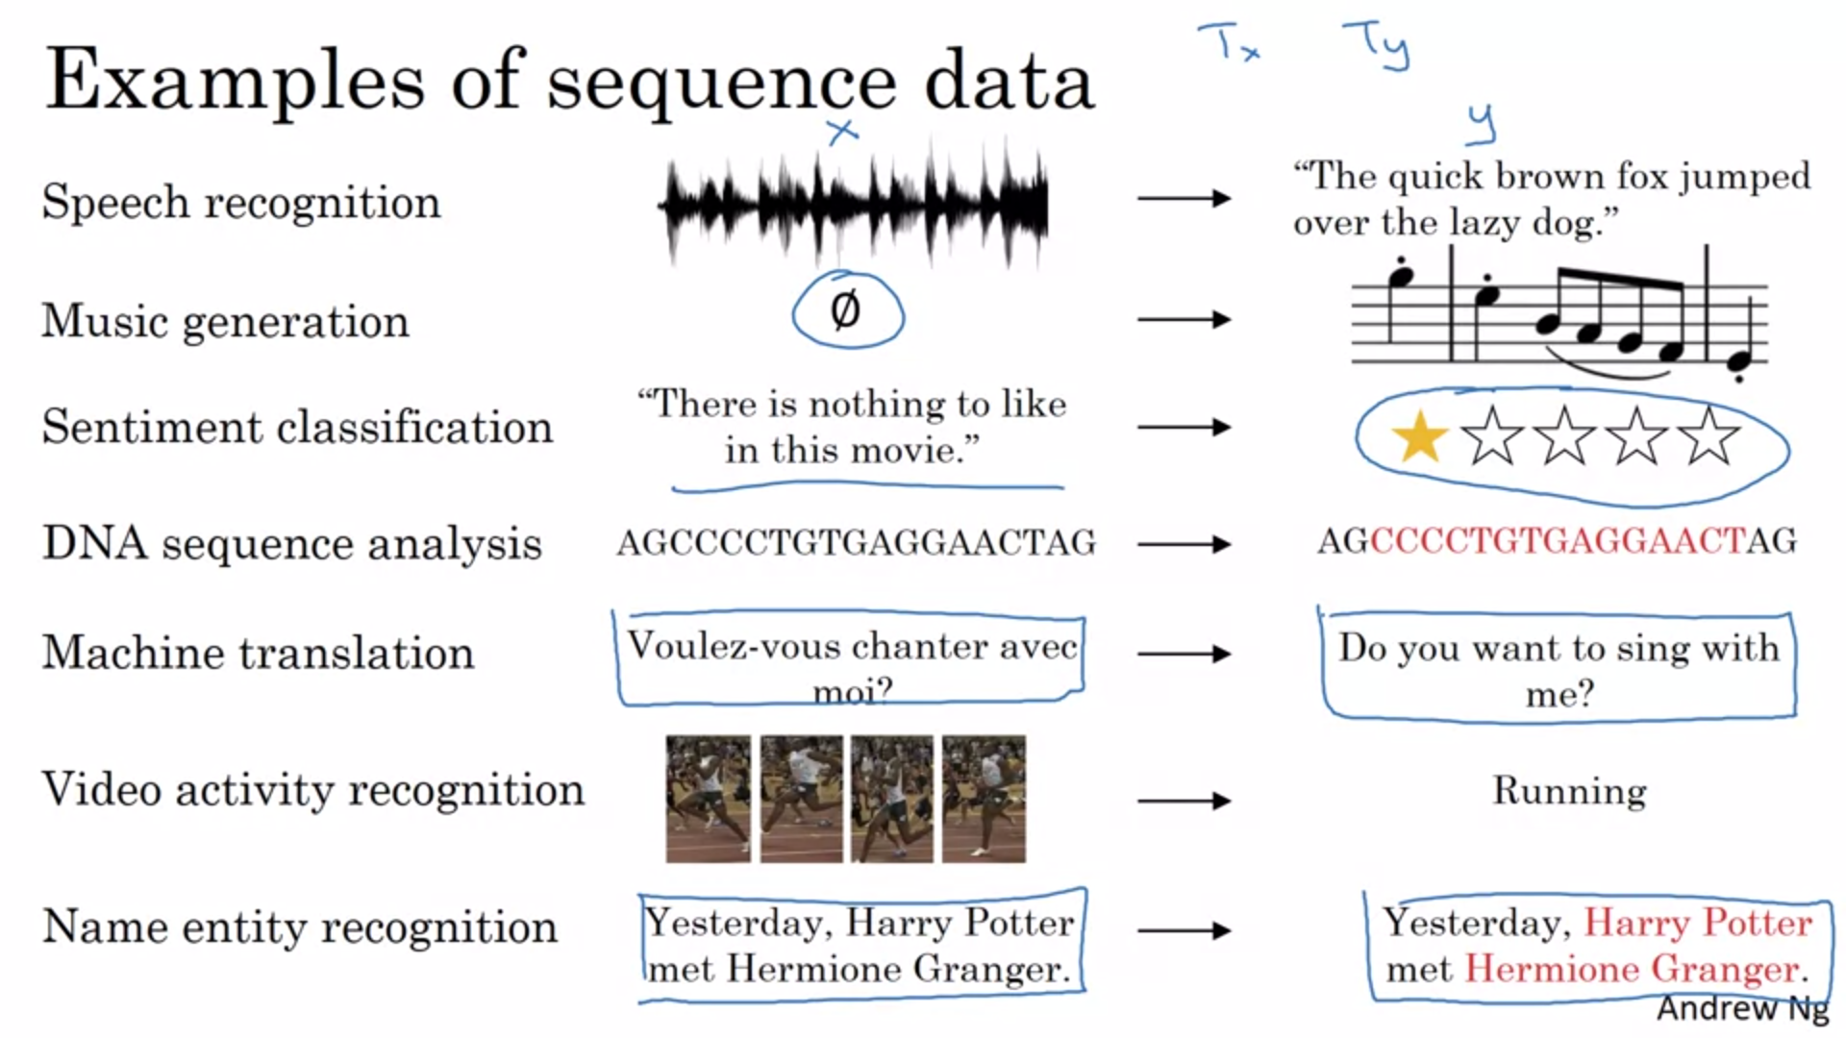

Input x and output y can be many different types.

E.g. sentiment classification: input sequence, output integer.

Machine translation: different length output.

We can modify the basic RNN architecture to adress all these problems.

Presentation of this section is inspired by a blog post of Andrej Karpathy titled “The unreasonable effectiveness of recurrent neural networks”.

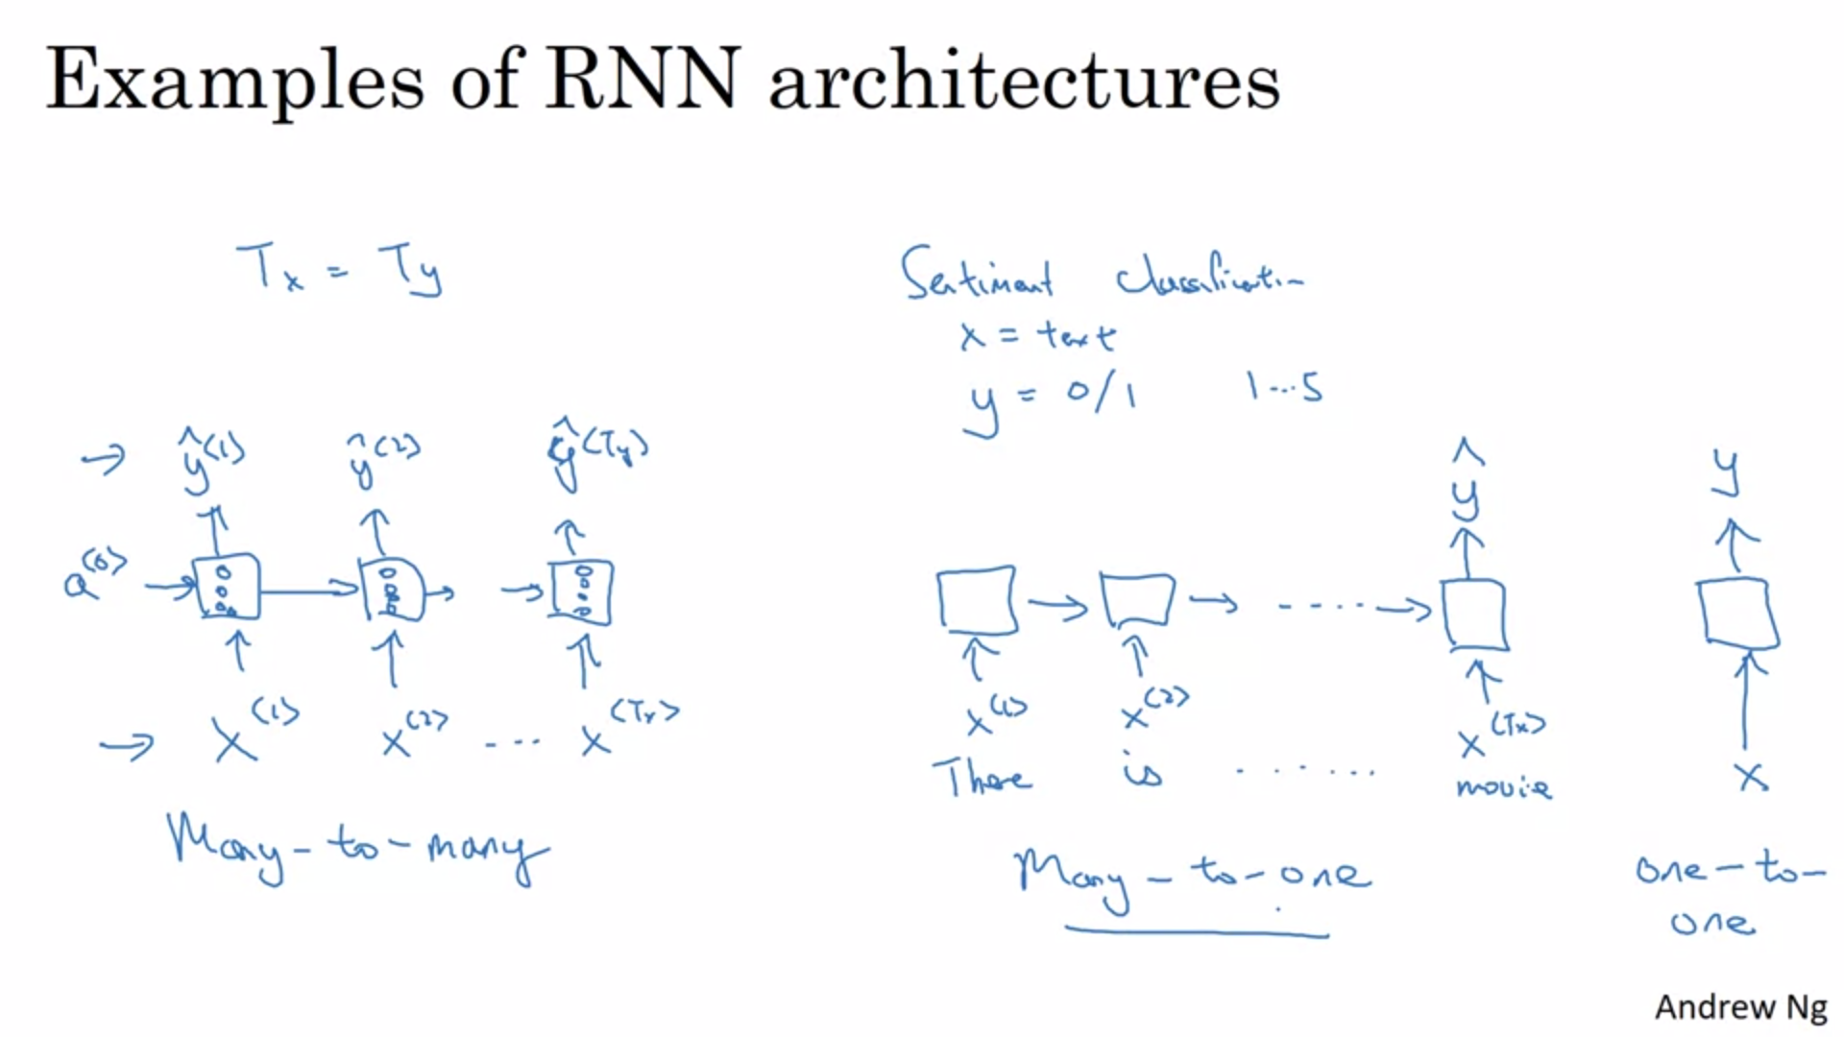

Sentiment classification: e.g. movie reviews. RNN will first read in the entire input and then output y in the last time step.

For the sake of completeness there is also a one-to-one architecture. One-to-one is just a plain (vanilla) NN.

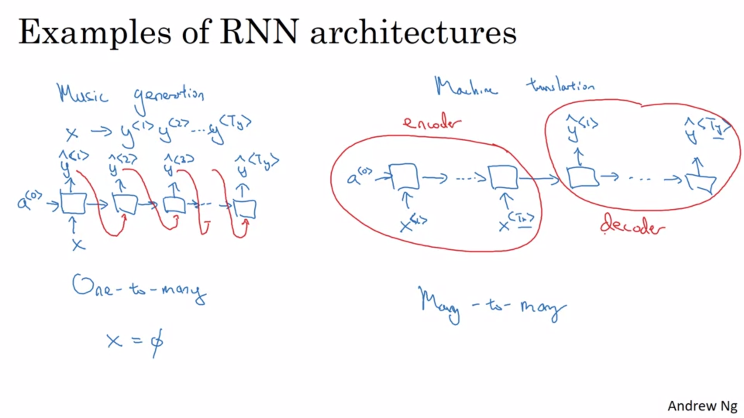

Example for one-to-many: music generation (s. programming exercise for details). Input x could be integer for genre or first note or even null input (vector of zeros). Output is a sequence of notes.

Often the output is fed back into the next layer.

Many-to-many with different input and output lengths is very interesting as well. Neural network architecture with two distinct parts -> encoder and decoder.

Attention-based architectures are not clearly captured by any of the above diagrams but they are covered later.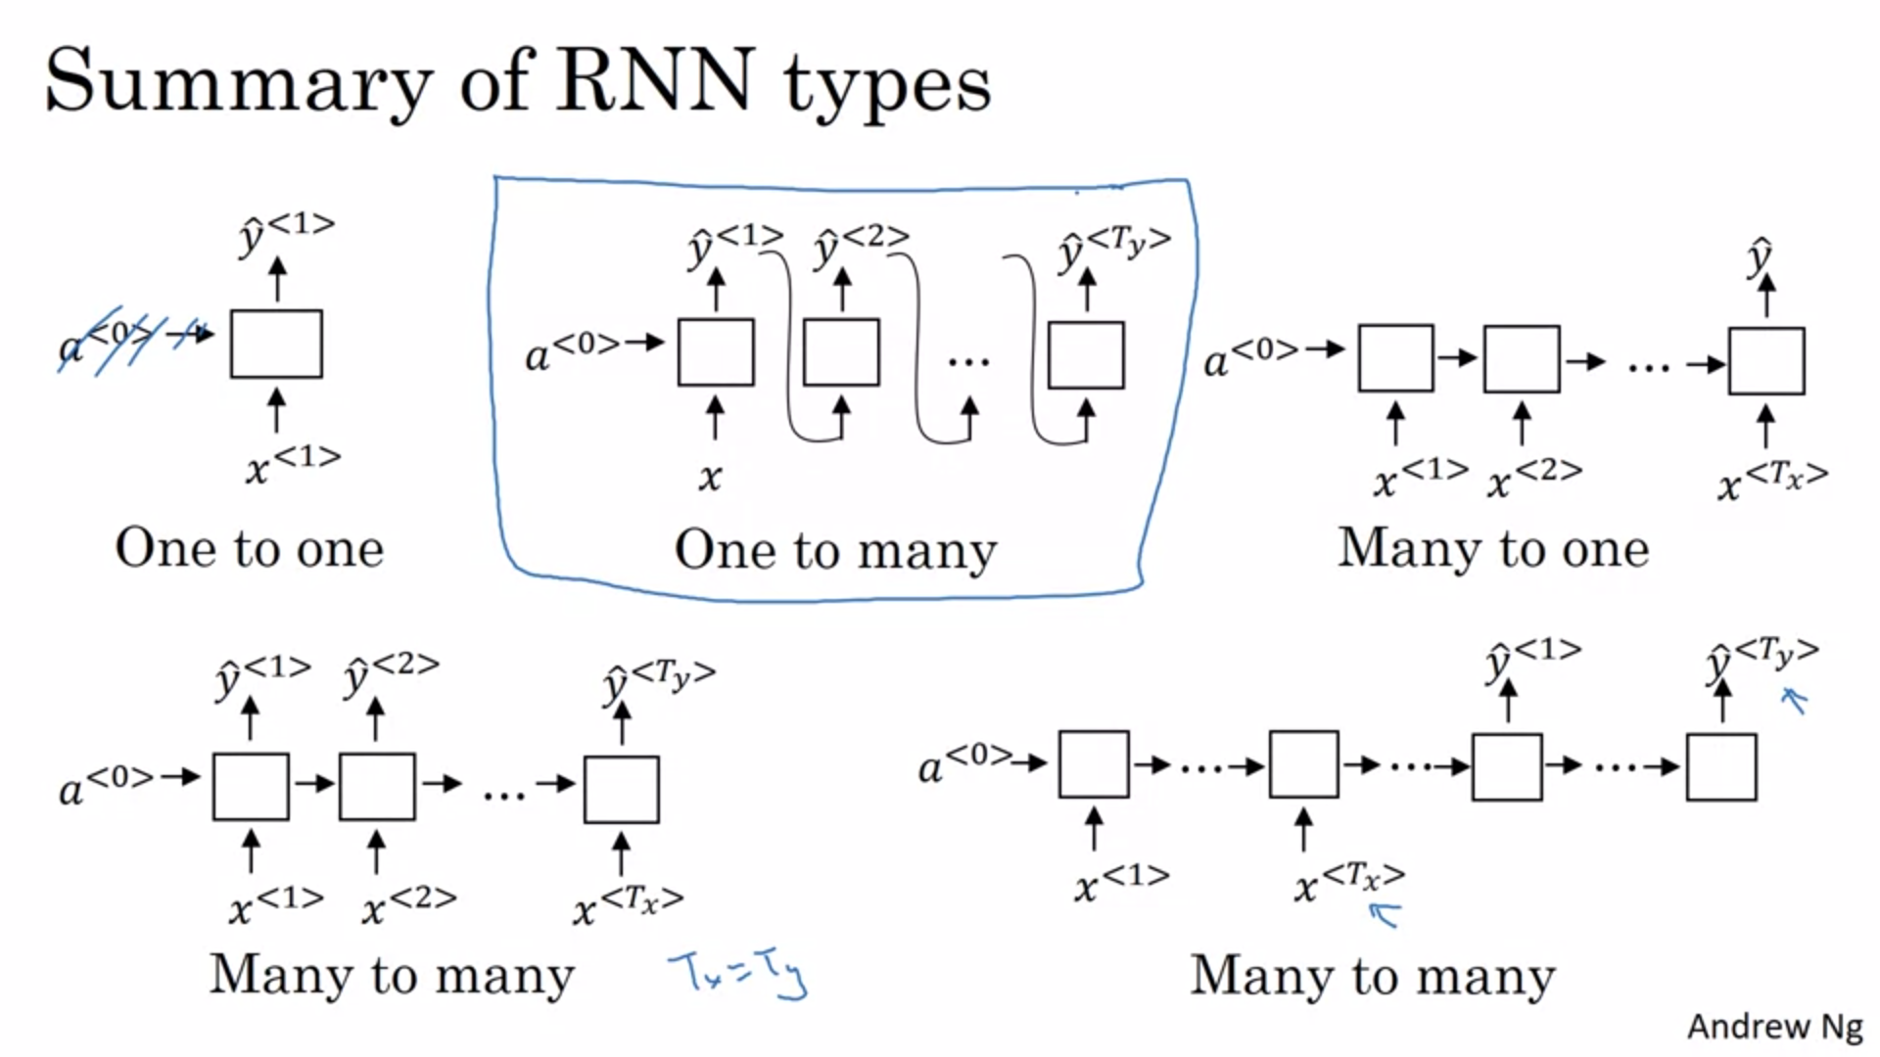

One to one: standard generic neural network

One to many: music or sequence generation.

Many to one: sentiment classification (e.g. movie review)

Many to many: name entity recognition.

Many to many other version: machine translation.

Now we know most of the building blocks for building all these different types of networks.

There are some subtleties to sequence generation.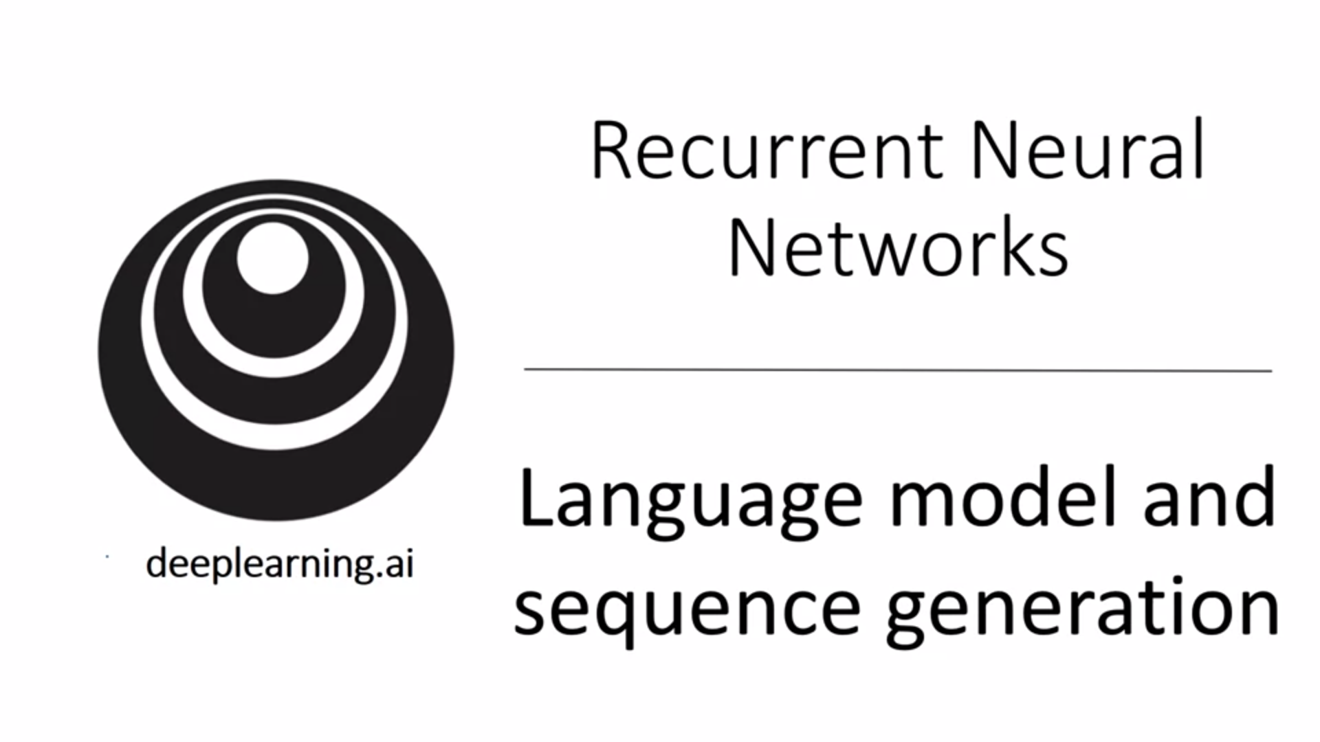

Language modeling is one of the most basic and important tasks in natural language processing. It is also one where RNNs do very well. In this section we will learn how to build a language model with an RNN.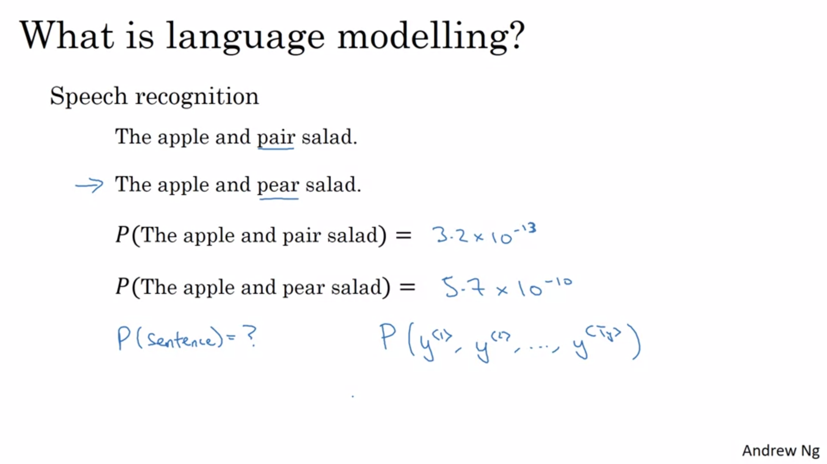

A good speech recognition system will output that the second sentence is much more likely (even though the two sentences sound exactly the same).

Here second sentence is much more likely (by over a factor of 10^3).

The job of a language model is to give probabilities for a sentence.

This is a fundamental component for both speech recognition and machine translation systems. They only want to output sentences that are likely.

Basic job of a language model is to input a sequence y and estimate the probability of that particular sequence of words.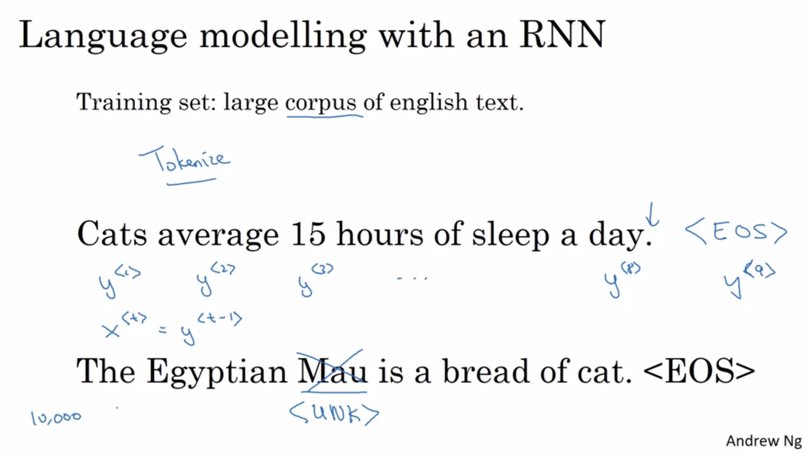

How to build a language model? We need a training set consisting of a large corpus of English text.

First step is to tokenize the sentence and form a vocabulary. Map each word to one-hot-vectors / indices of your vocabulary.

We add EOS for end of sentence token so that the model can capture when a sentence ends.

The period can be a token as well.

What if some of the words in the input sentence are not in the vocabulary? E.g. vocabulary of top 10k tokens. We can replace the word with <UNK> (unknown) token.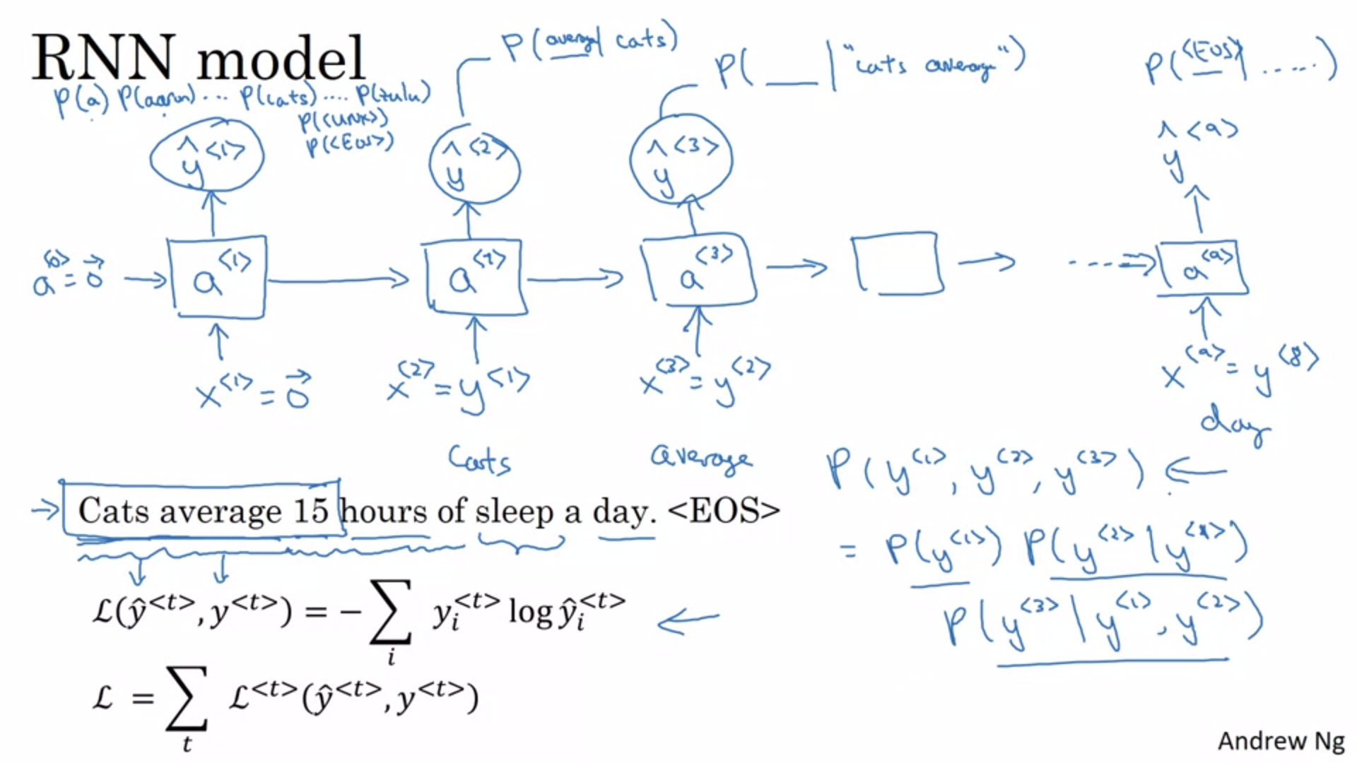

Let’s build an RNN to model the chance of these different sequences. We will set the inputs x<t> to be equal to y<t-1>.

At time 0 we will set x<1> to a vector of 0s. Also previous a<0> is a vector of all zeros. There is a softmax activation function to calculate the chances for different first words. 10k+2 softmax output for 10k words and 2 additional tokens.

Then RNN steps forward. Now we pass y<1> as input x<2>.

For third word we can give the first two words as input. x<3> will be y<2>.

Each step of the RNN will look at a set of preceding words. RNN will predict 1 word at a time, going from left to right.

To train the network we will define the loss function next. This will be the softmax loss function. The total loss will be the sum over the losses of the individual predictions across the sequence.

If RNN is trained on large enough dataset it will be able to give a prediction for the next word given an input sequence of e.g. 3 words.

Multiplying conditional probabilities we will end up with the joint probability.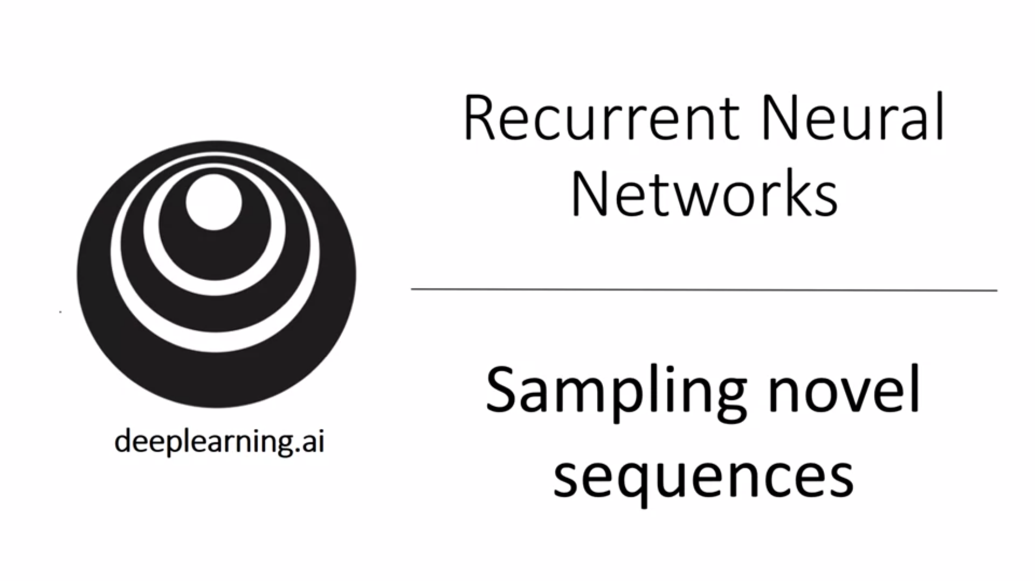One of the most fun things to do with a language model is sampling novel sequences.

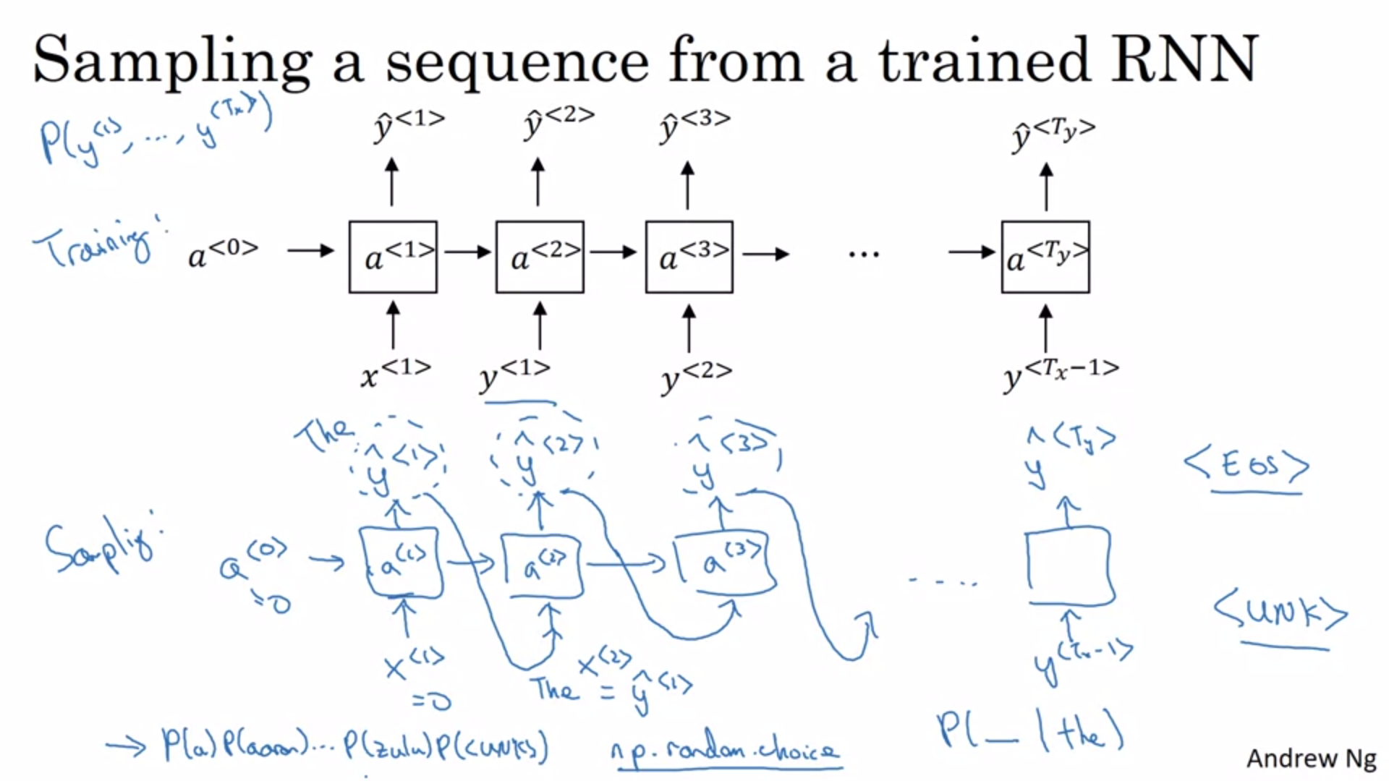

Sample from the learned probability distribution.

First sample first word by feeding x<1> and a<0>. Random sample from softmax output.

Pass the sampled word as input in the next timestep.

Keep going until <EOS> token or alternatively decide to sample 20 or 100 words for example.

Samples with <UNK> word token could be rejected if not desired.

So far: word-level RNN, meaning that the vocabulary consists of words. Depending on the application a character-level language model could be built instead.

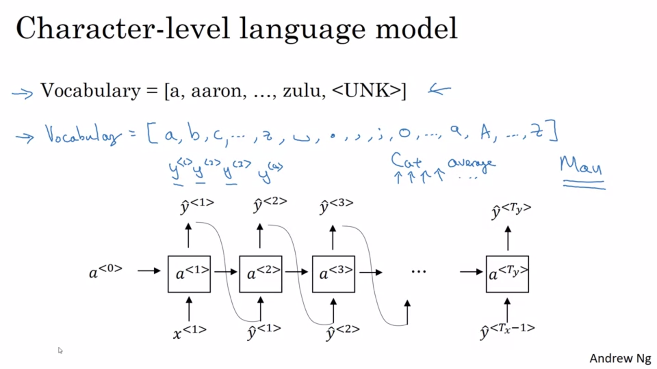The sequence are now the individual characters in the training data. The space would be y<4>.

Some pros and cons of character-level language model: no <UNK> token as in word-level language model; main disadvantage is that you end up with much longer sequences and it is hard for the models to capture long range dependencies; also more computationally expensive to train.

For the most part word-level language models are still used but as computers get faster and faster there are more character-level language model applications.But still not widespread. Mostly in specialized applications.

.

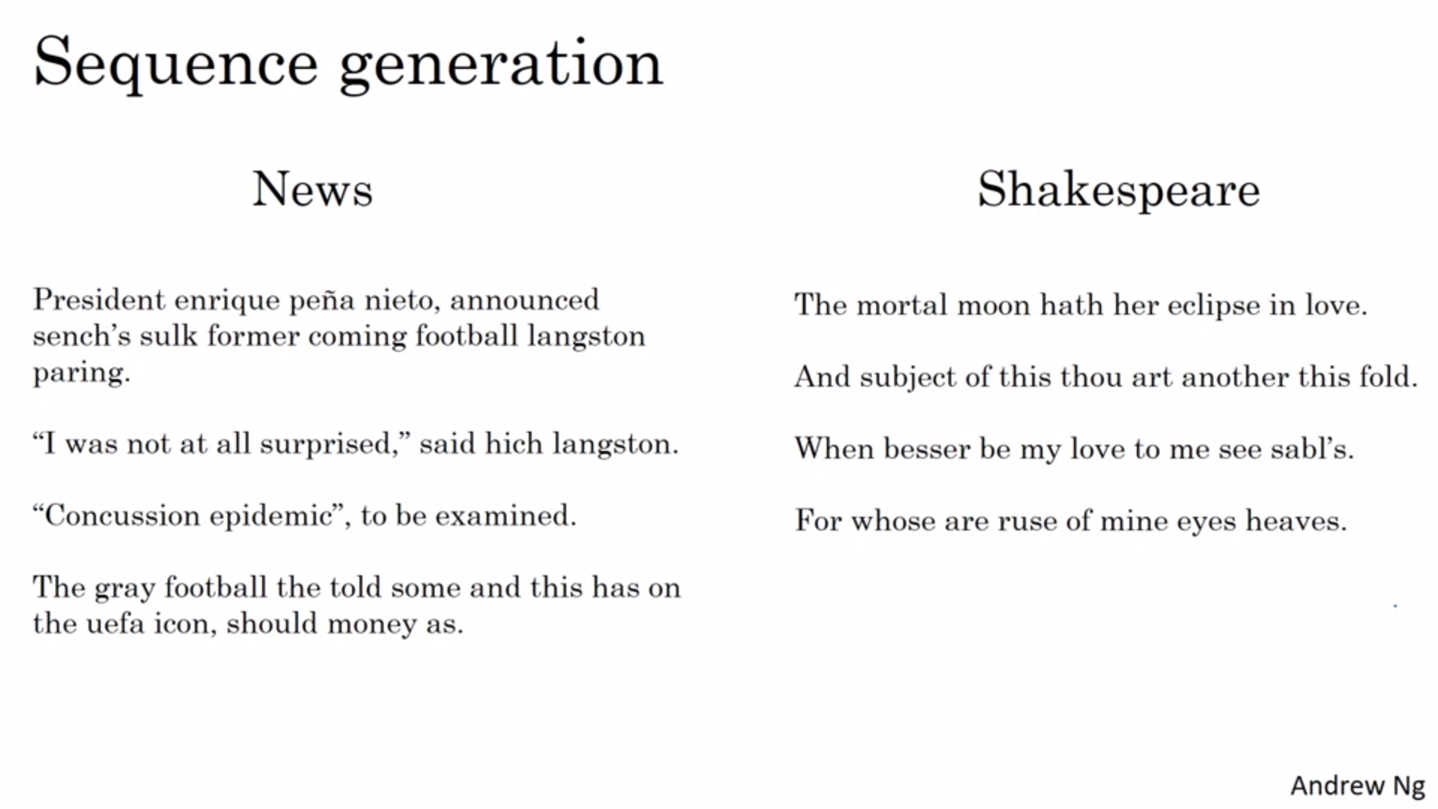

Some fun examples of text generated by a character-level language model.

We have learned how to train a language model (character-level and word-level) and how to sample from it.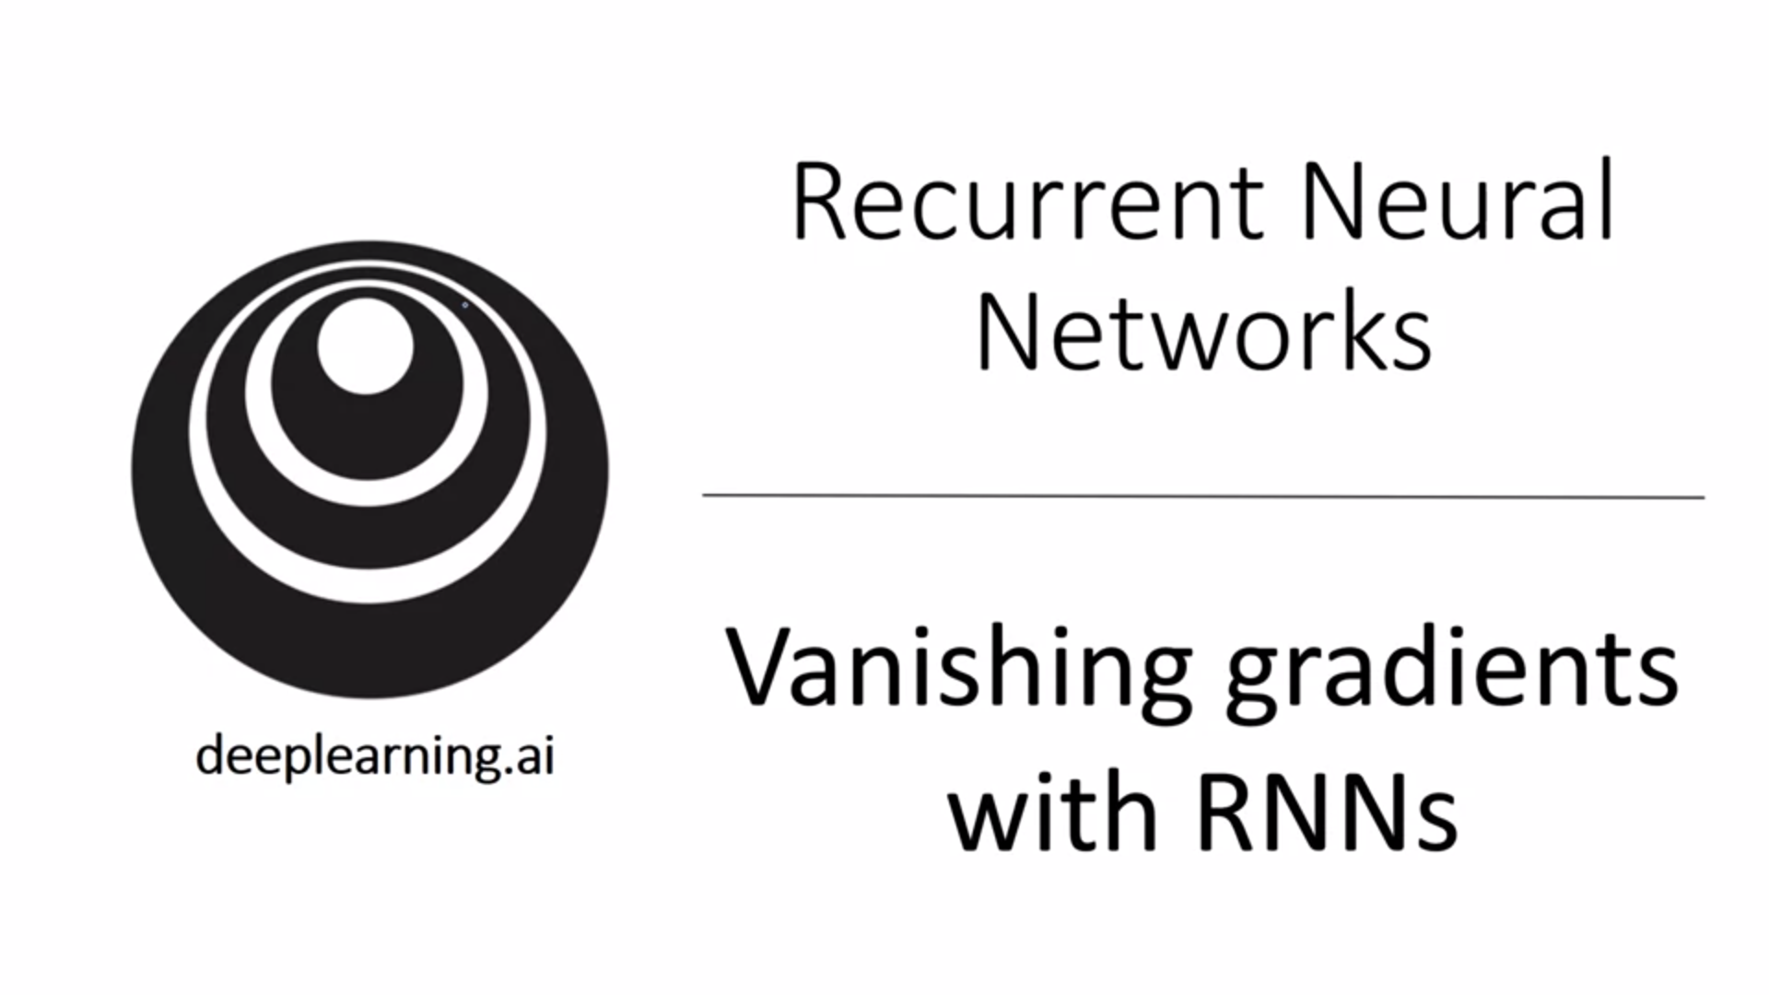

Discuss further some of the challenges of RNNs and how to tackle them with even more powerful models.

We have seen how RNNs can be applied to problems such as name entity recognition and language modeling. Also we have seen how backprop can be used to train an RNN.

One of the main problems of RNNs is that it runs into vanishing gradients

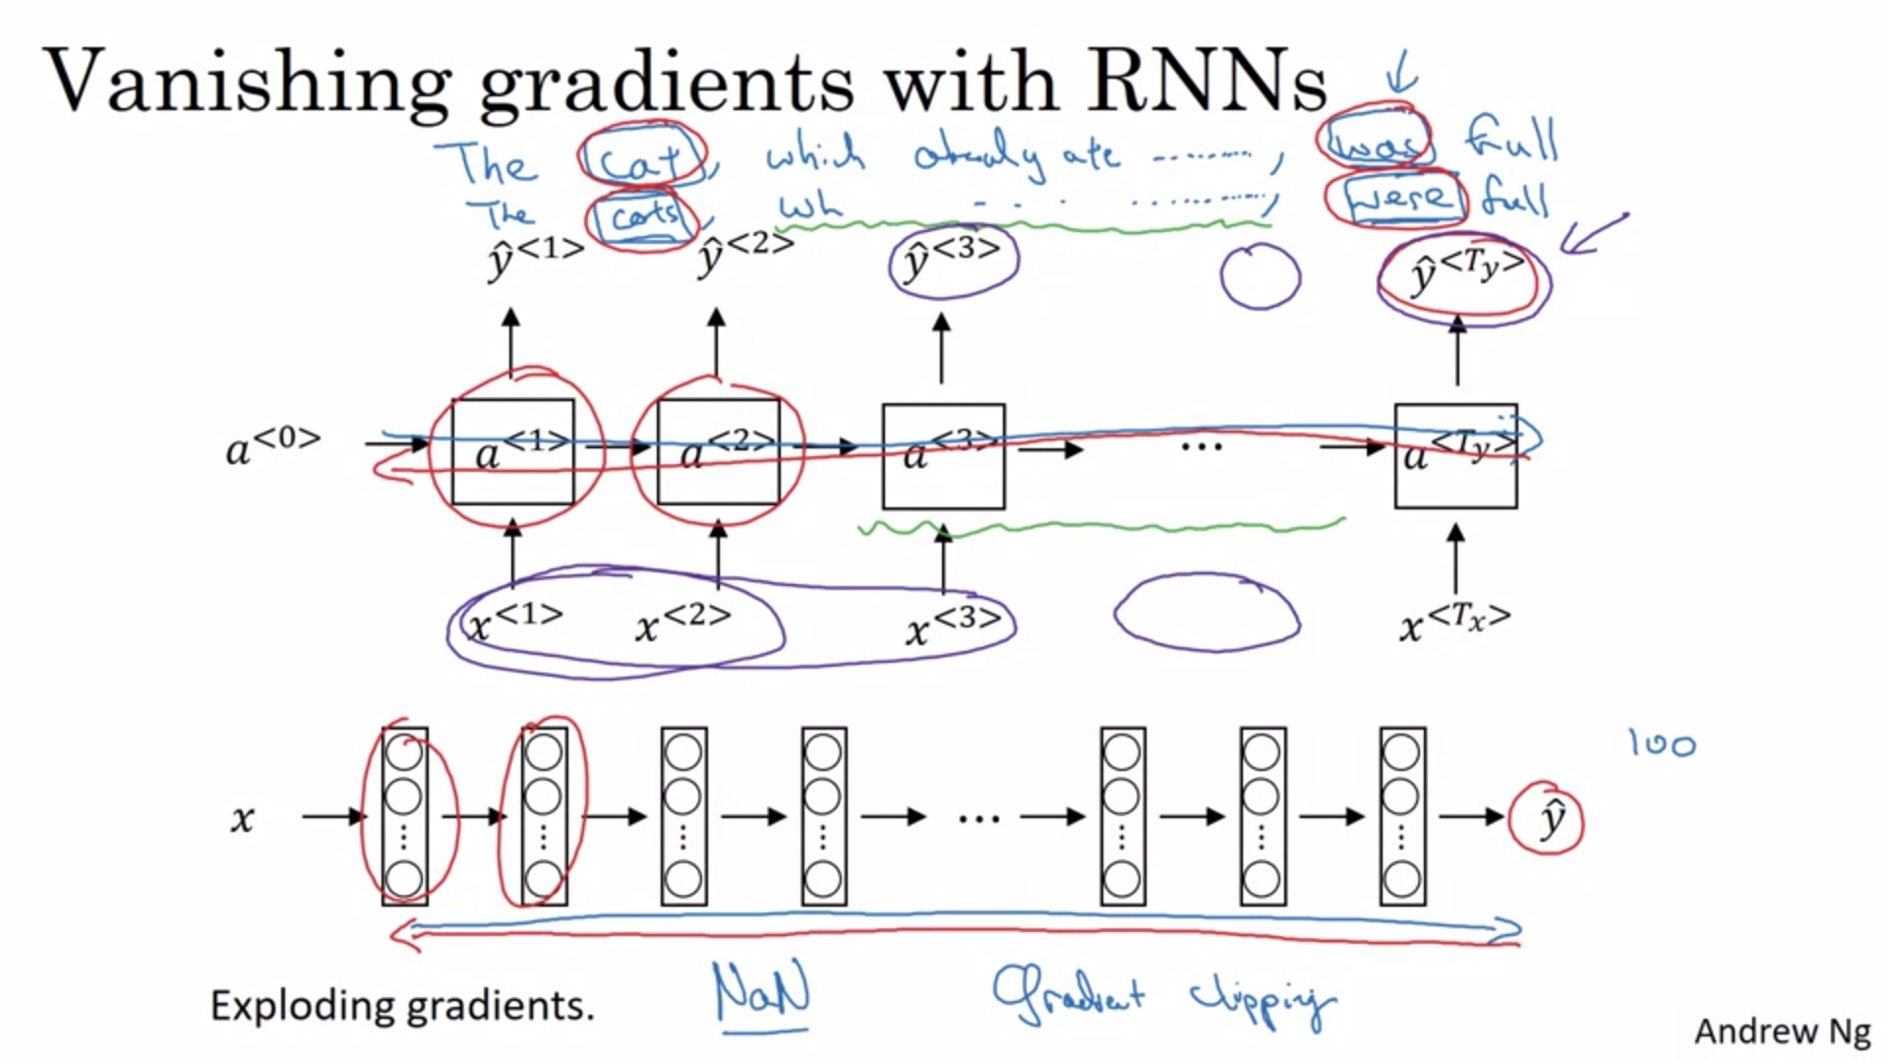Example “cat was” vs “cats were”. Singular vs Plural. This is an example for a long range dependency in language.

The basic RNN is not very good at capturing long-term dependencies. It is mainly influenced by local (close) inputs.

We talked about vanishing gradients earlier with very deep neural networks.

Vanishing gradients: the gradient from output y_hat has a hard time to propagate back to affect weights of earlier layers. We have the same problem with RNNs.

In practice this means that it becomes difficult for the network to memorize whether there is singular or plural noun when deciding the verb. It is difficult for an input early in the sequence to influence the output later in the sequence.

If this problem is not addressed, RNNs are not very good at capturing long range dependencies.

There is also the problem of exploding gradients with deep neural networks. Vanishing gradients is the more common problem than exploding gradients with RNNs.

Exploding gradients is easy to detect as the parameters blow up and we often see NaNs (numerical overflow). One solution to exploding gradients is gradient clipping (if gradients surpass a threshold, then clip them to a maximum value). Gradient clipping is a quite robust solution.

Vanishing gradients will be the subject of the next few slides.

An RNN processing data over 1k or 10k timesteps is basically like a 1k or 10k layer neural network.

GRUs are a very effective solution to tackle the vanishing gradient problem and allow sequence models to capture much longer range dependencies.

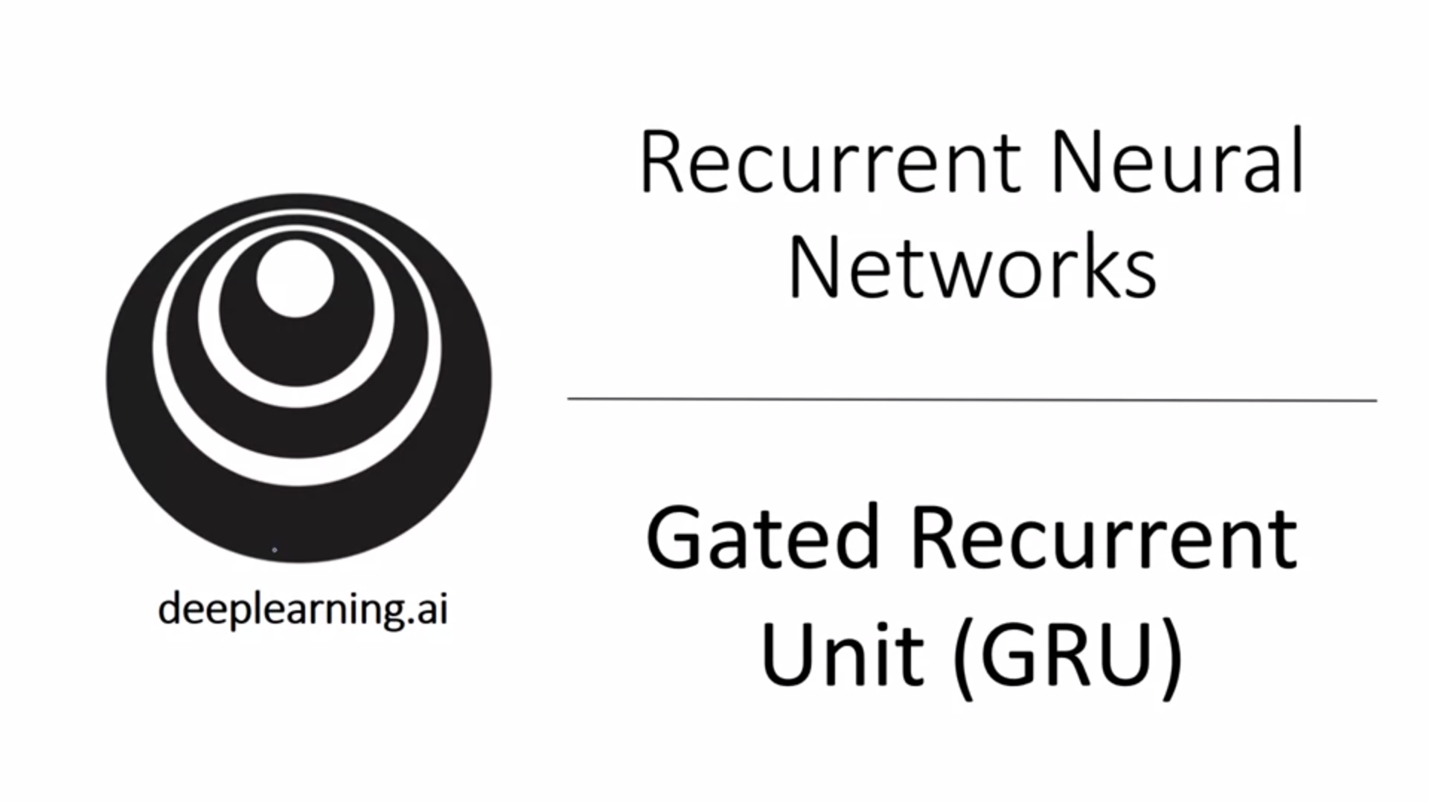GRU: modification to the RNN hidden layer that makes it much better at capturing long range connections and tackles the vanishing gradient problem.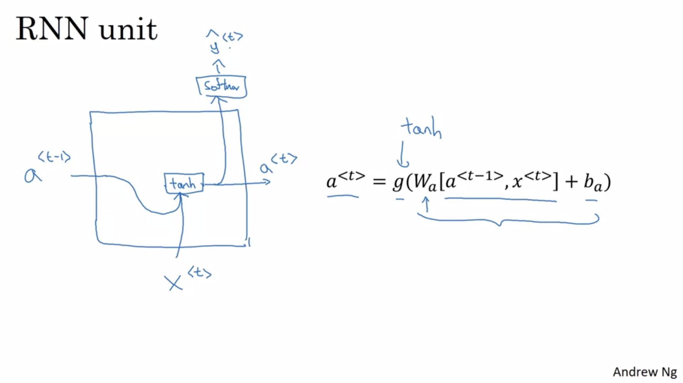

Visualization of the hidden layer of the RNN (RNN unit). We will use a similar picture for the GRU.

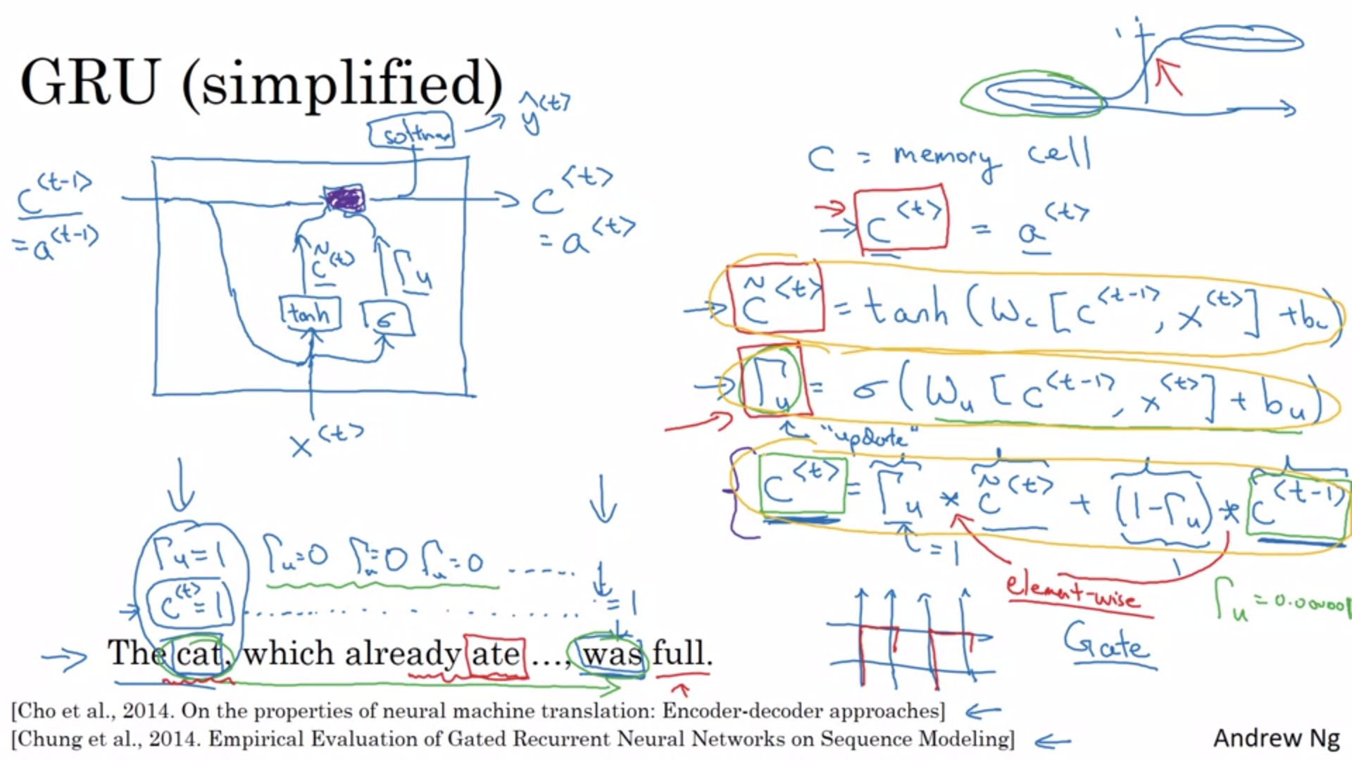

GRUs were due to these two papers listed here.

Sentence here is a reminder of the need to memorize singular vs plural.

c -> memory cell

a -> output activation value

Here a and c are the same but this will not be the case for LSTMs.

c_tilde -> candidate for replacement of the memory cell. At every time step we consider an overwrite.

Current input value as well as previous value of c_tilde + bias are passed to calculation of c_tilde.

The important idea of the GRU is that we will have a gate, called GAMMA_u. Think of it as always being 0 or 1 for intuition although in practice it is computed with a sigmoid activation function. For most of the input values, the sigmoid activation function is either 0 or 1.

Gate is denoted as GAMMA: it fits into the fence drawing.

The gate will decide whether we actually update the memory cell with c_tilde.

Example in the left bottom of the slide: memory cell set to 1 for cat and then gates will ensure that memory cell stays in tact until verb. Update memory cell during cat and afterwards don’t update it. When a “new concept” is introduced, it would be a good time to update the memory cell.

Pictures of the cell are very common to explain GRUs, LSTMs…

Purple box represents purple operation.

This is a slightly simplified version of the GRU.

The gate is quite easy to set to 0 (input value -> large negative value). In that case the memory cell will maintain its value. This is why it does not suffer from the vanishing gradient problem.

c, c_tilde and GAMMA_u are the same dimension. The asterisks are element-wise multiplications. GAMMA_u is really a vector of bits (intuition-wise) that tells us which parts of the memory cell vector to update. We can keep some bits constant while updating other bits.

Example: some bits can memorize singular or plural, others can memorize that the sentence is about food.

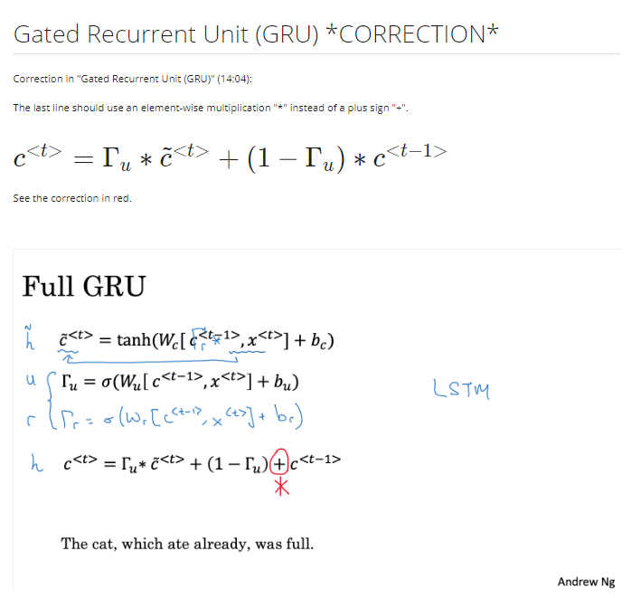

Now we look at the non-simplified GRU. We copy the three main equations from the previous slide.

One chaner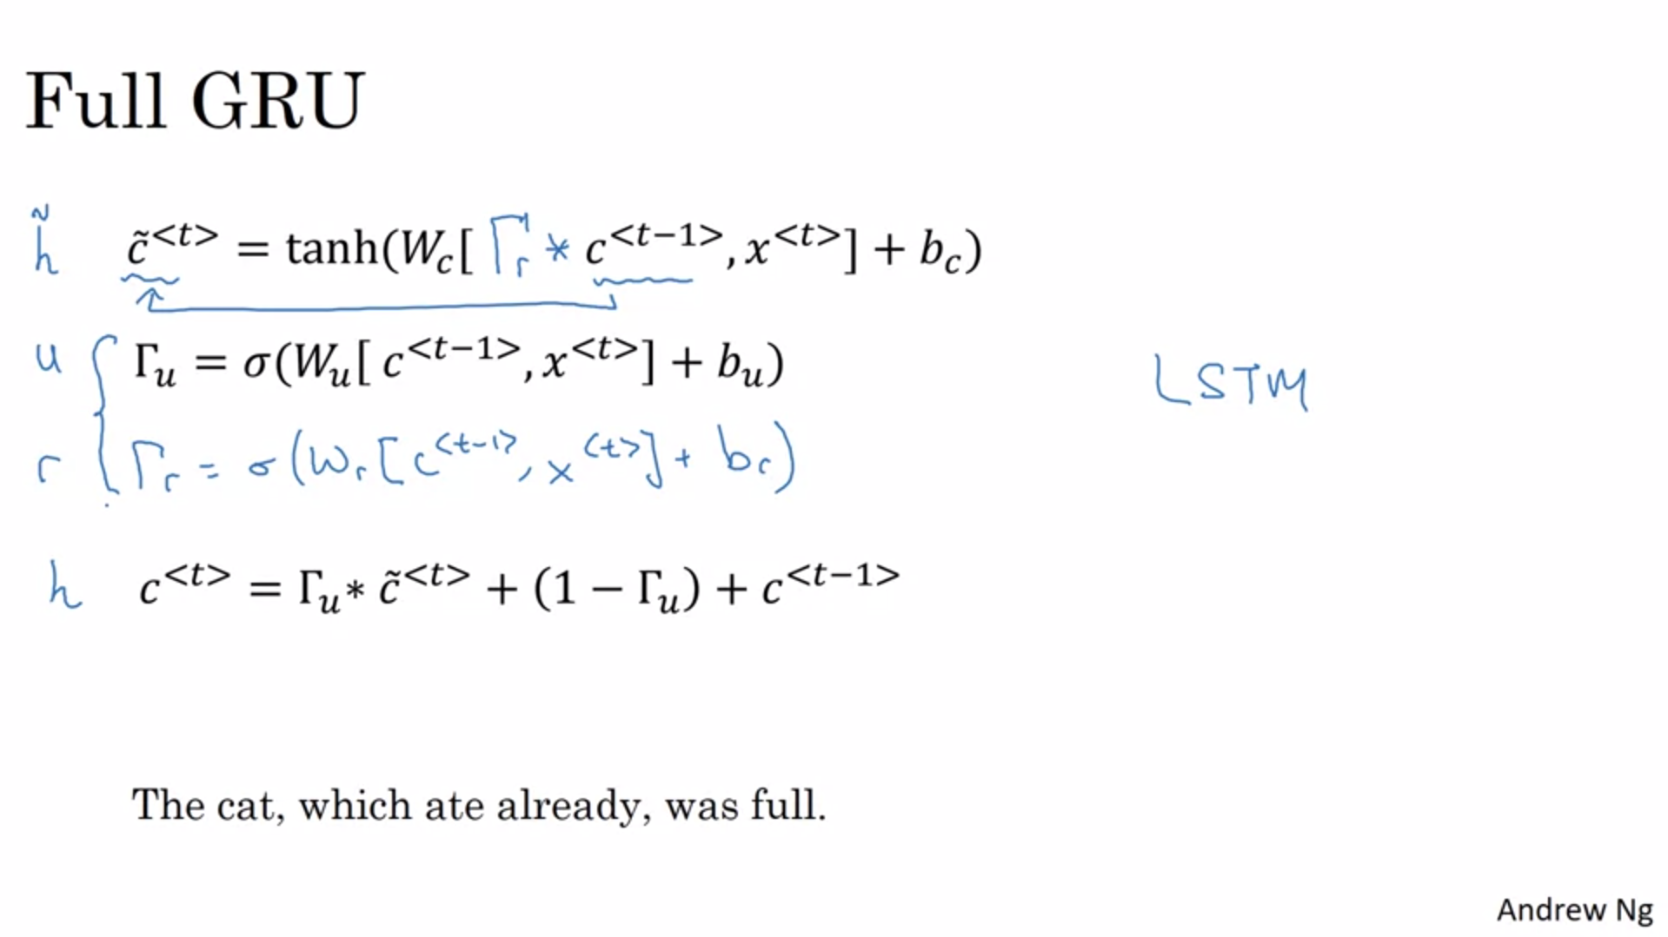

We make one change to the equation calculating the candidate for the memory cell. We add another gate GAMMA_r (r standing for relevance). It is to consider the relevance of the previous memory cell value for the new candidate. It is computed as can be expected with a sigmoid activation function.

There are multiple ways to come up with architectures. Researchers experiment with different setups for these units. GRUs is one of the common versions that researchers have converged to.

The other common version is LSTM.

In the academic literature, sometimes different notation is used to denote certain quantities.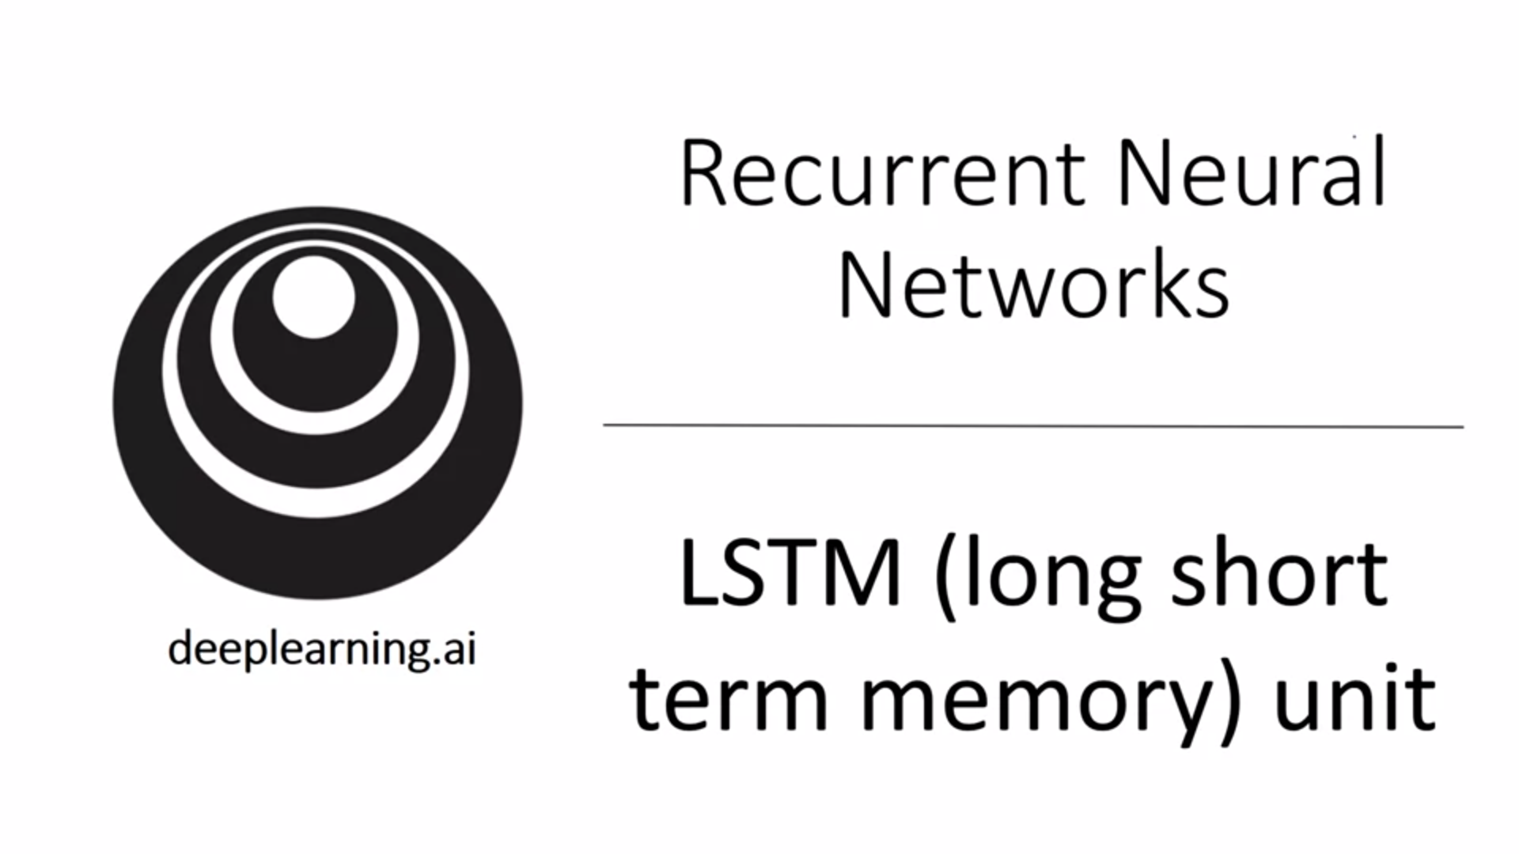

LSTM also allows to learn very long-range connections in a sequence. It is even more powerful.

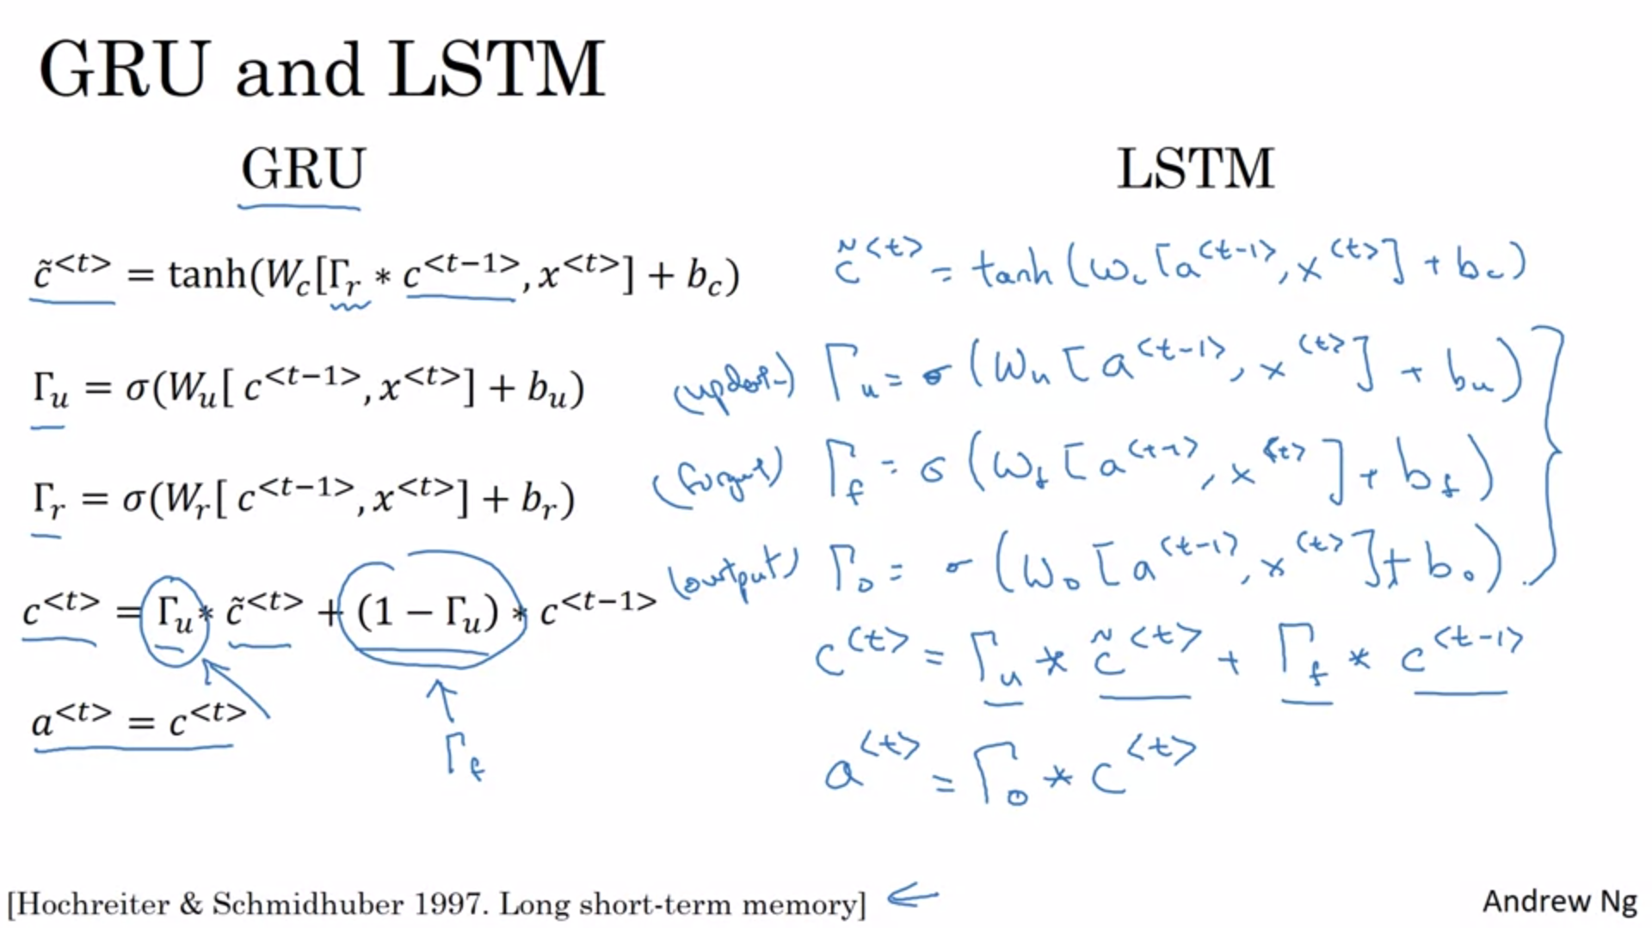

LSTM is a more powerful and general version of the GRU and is due to the paper mentioned on this slide. This was a huge impact paper but quite difficult to read (goes into the details of vanishing gradients).

For the LSTM, a is no longer equal to c.

The common version of the LSTM does not have GAMMA_r gate.

There are two different gates to control the memory cell in a LSTM (update and forget gate). In GRU we only had one gate GAMMA_u.

New output gate GAMMA_o.

The memory cell now has the option to keep its value but adding on top (thanks to separate update and forget gate).

The activation is equal to the output gate multiplied element-wise with the “activated” memory cell (see next slide).

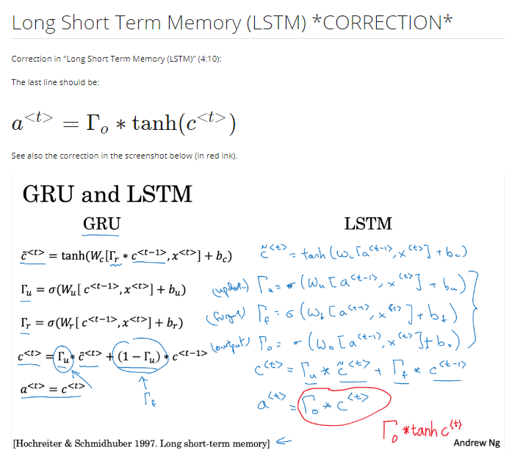

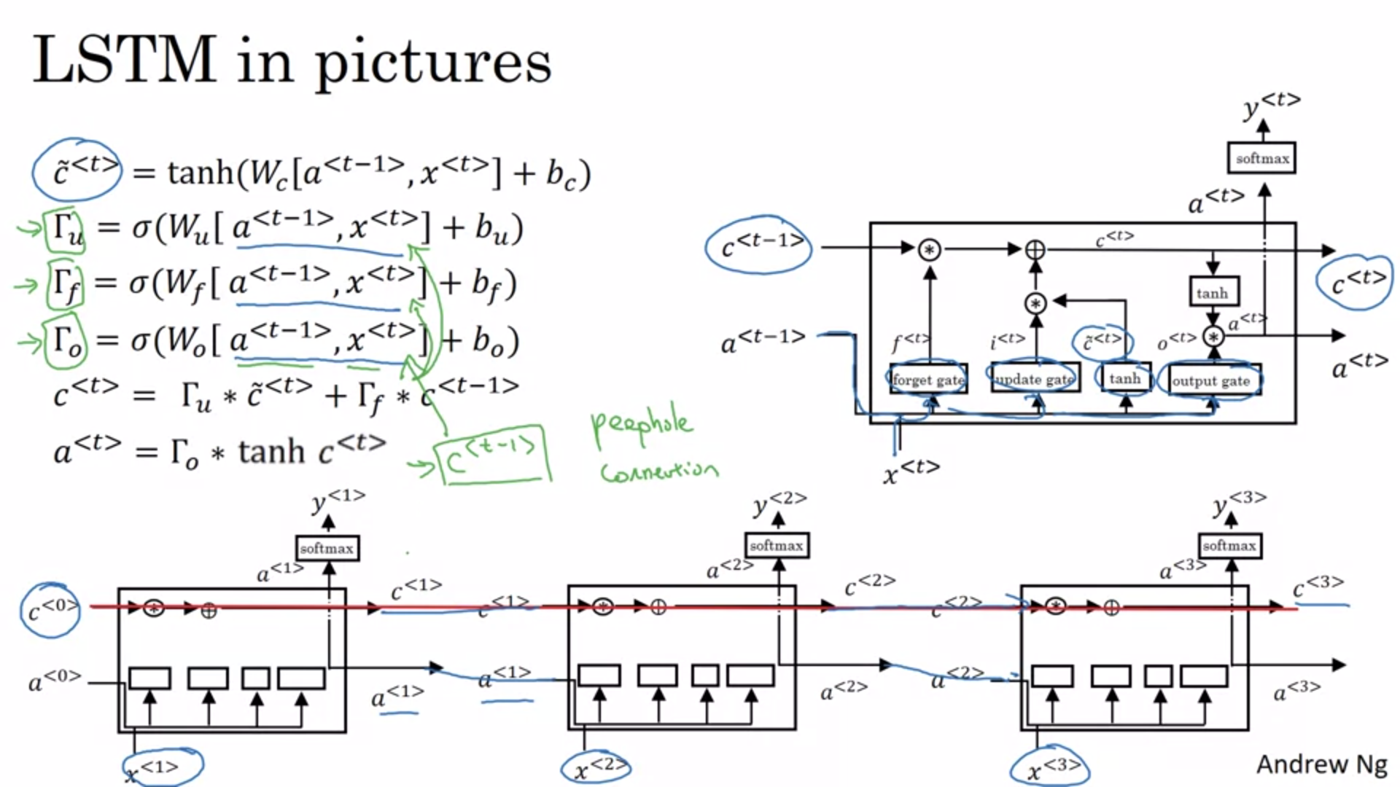

Picture inspired by blog post “Understanding LSTM networks.

Key takeaway: a<t-1> and x<t> are used to compute all the gate values.

Values are combined with elementwise multiplications: *

Connect multiple LSTM cells temporally. Outputs c<1> and a<1> of first cell are inputs for second cell.

The red line shows that as long as forget and update gate have the right values, it is easy for the LSTM to pass values all the way to the right (through this red highway). The LSTM (and GRU) are very good at storing values for even very long timesteps.

There are many variations that people use. Most common one is marked in green on the slide: peephole connection. Gates also depend on previous value of the memory cell. One technical detail is that these could be 100-dimensional vectors if you have a 100-dimensional memory cell. The 5th element will only affect the 5th element of the corresponding gate. There is a 1:1 relationship. Not all elements will affect all elements.

When to use GRU and when to use LSTM? There is no widespread consensus for this. Between LSTM and GRU there is no universally better algorithm. It depends on the problem.

LSTMs actually came much earlier in the history of deep learning than GRUs. GRUs were derived as simplification.

It is easier to build a large network with GRUs since it is a simpler model and it is computationally faster. The LSTM is more powerful and flexible. If you had to pick one, LSTM is the historically more proven choice.

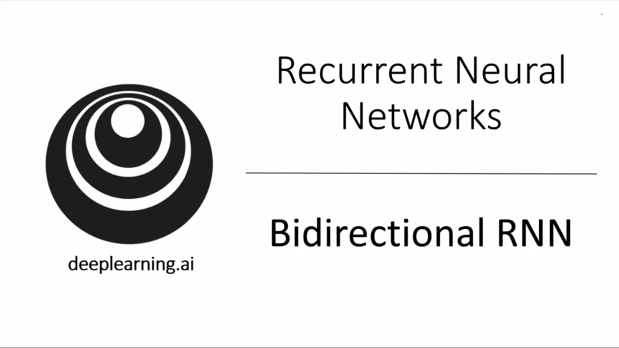

By now we have seen most of the building blocks for RNNs. There are two more ideas that let us build much more powerful models: One of them is bidirectional RNNs. These let us take information from inputs earlier and later in the sequence. Second is deep RNNs which will be the next topic.

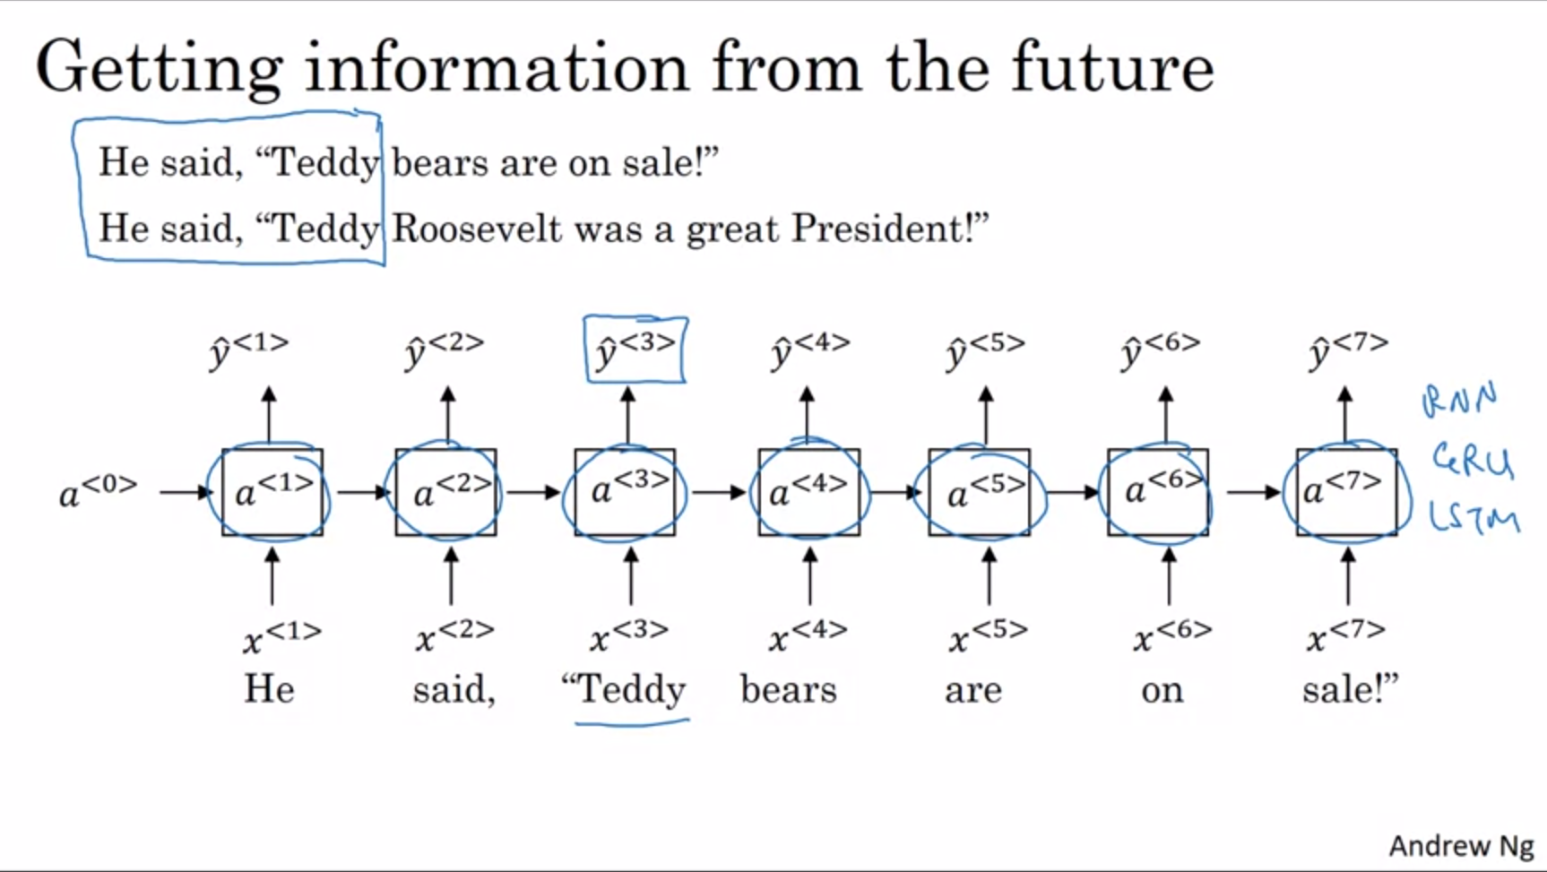

Past example: name entity recognition -> to figure out whether Teddy is a person’s name it is not enough to just look at the first part of the sentence. We need more information.

So far: unidirectional / forward-directional RNN.

Bidirectional RNN can apply to normal RNN but also to GRU and LSTM blocks.

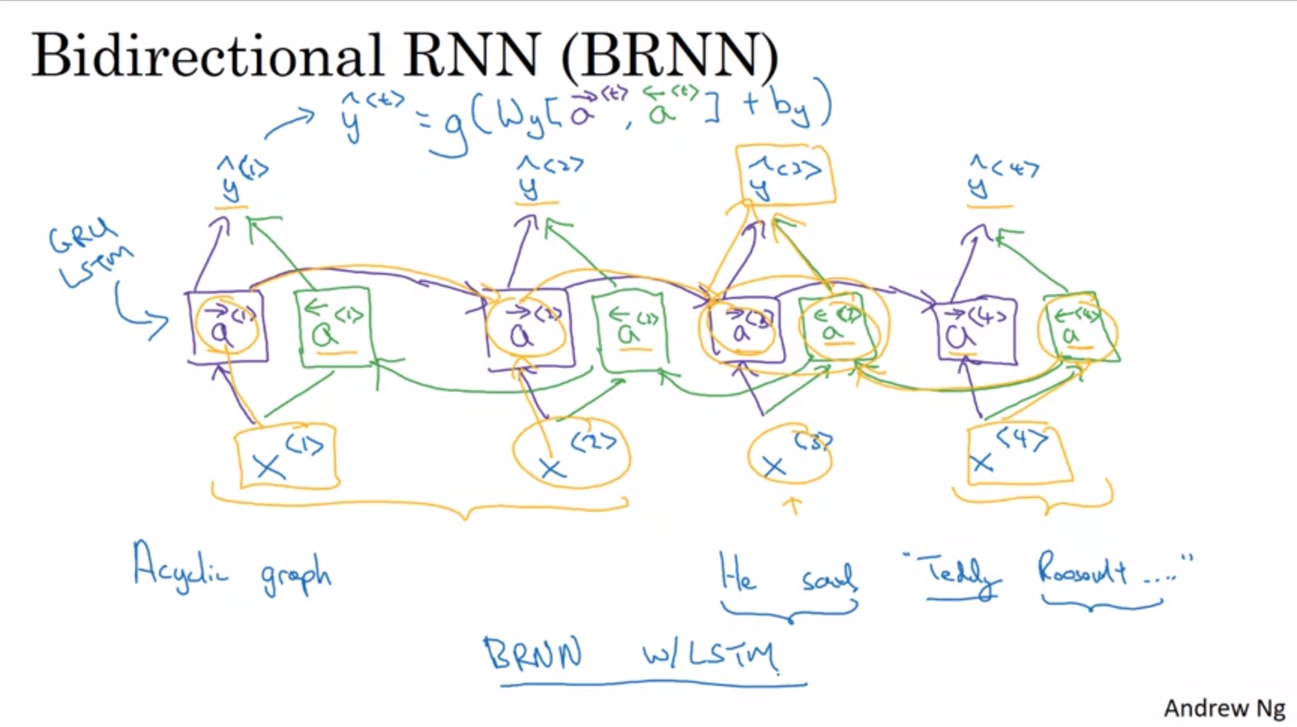

The bidirectional RNN fixes this issue. E.g. 4-word sentence here. Forward recurrent component in purple. Backward recurrent component in green. Notice that this is not backprop but forward prop where we calculate the activations. Part of the computation is going from left to right and part is going from right to left.

This network defines an acyclic graph.

Predictions can only be made once all activations have been calculated. Output is calculated from both forward and backward computation.

Information from x<4> can now flow back to y<3> for example. We can take into account information from the past, present and future.

Again, these blocks can be standard RNN blocks or GRU/LSTM blocks. BRNN with LSTM block is commonly used for NLP problems. It is reasonable thing to use for a first try.

The disadvantage of the BRNN is that the entire sequence of data is needed before predictions can be made anywhere. E.g. for speech recognition you need to wait for the person to stop talking before you can start processing and make the prediction. Nonetheless, for applications where this is not a problem and the sequence is available, this algorithm is very effective.

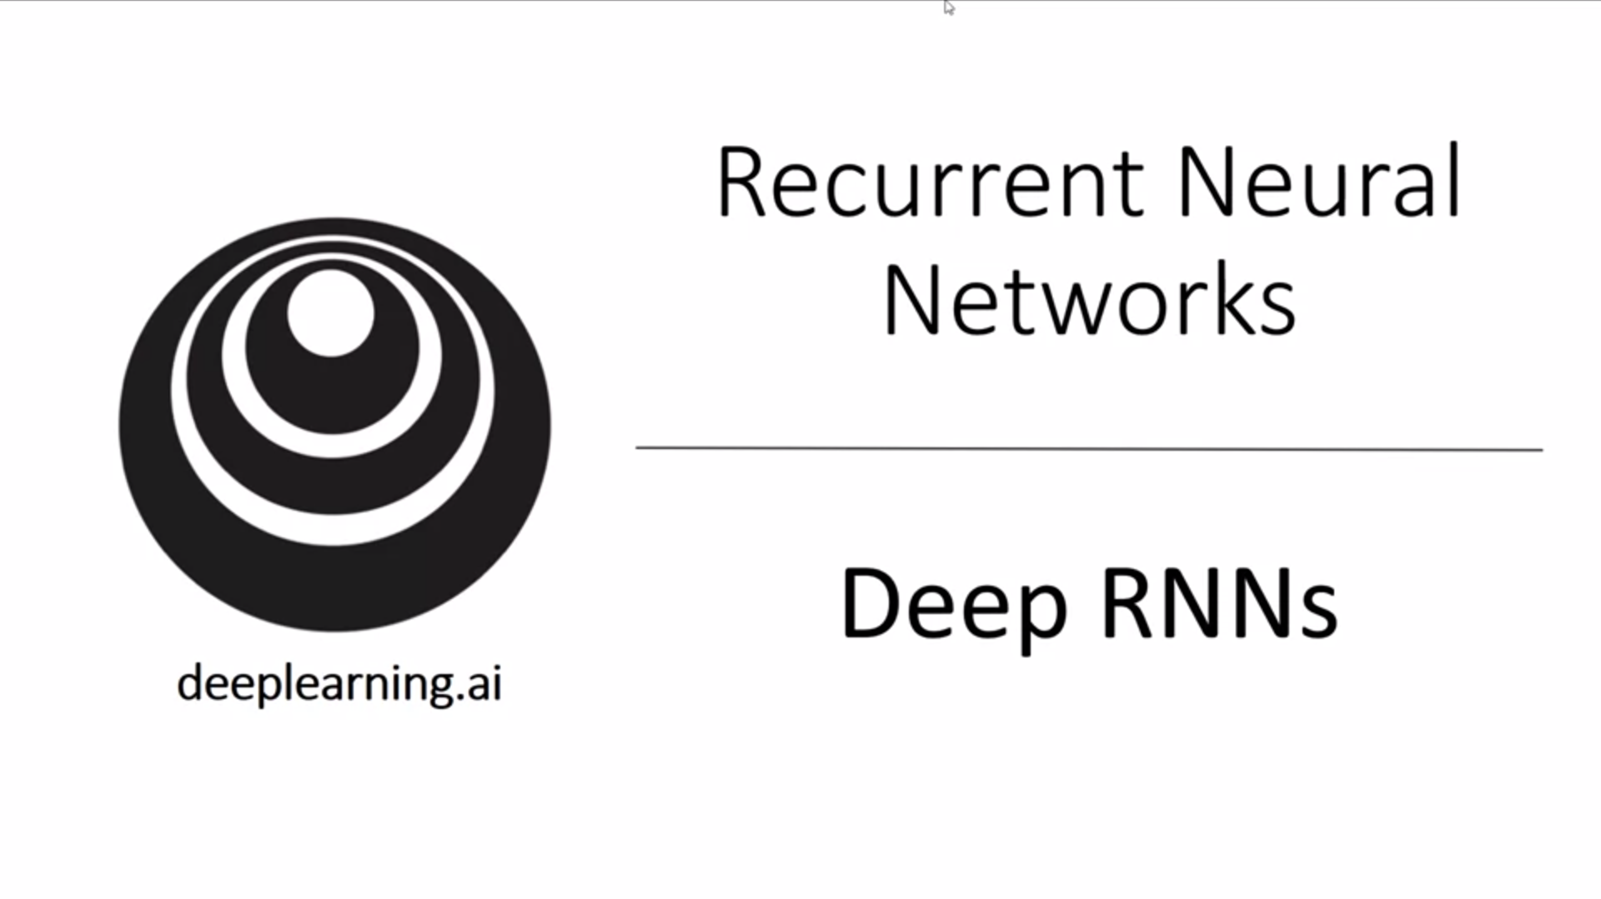

For learning very complex functions, it can be useful to stack together multiple RNN/GRU/LSTM or BRNN layers to build deeper versions of these models.

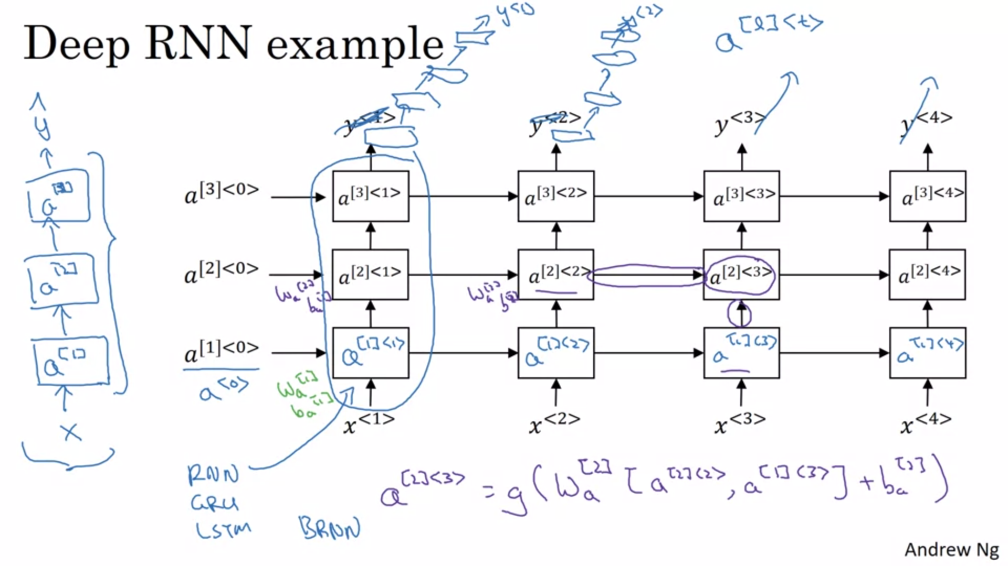

Unroll left network in time. The square bracket now denotes the layer.

As an example we look at how a[2]<3> is computed. It has two direct inputs (from bottom and from left). Same parameters are shared for all computations in the same layer. Parameters are not shared across layers.

For RNNs having three layers is already quite a lot because of the temporal dimension. That would already be a big network.

What is quite common is to have stacked RNNs but then also stacked normal (not connected) deep layers before calculating the output.

Here as well you can use standard RNN blocks or GRU/LSTM blocks. Also it can be bidirectional.

Deep RNNs are quite computationally expensive to train. You usually not see many deep recurrent layers.

Now we have a rich toolbox to construct very powerful sequence models.